FlowScan – All In one Finance Calculator

**Data Flow Coverage Criteria Software Testing**

*Guided By*

|  |
| --- |
| **Meenakshi D Souza** |
| **Professor** |
| **International Institute of Information Technology, Bangalore** |

**

**International Institute of Information Technology, Bangalore**

*Created by:*

|  |  |
| --- | --- |
| **Mohit Gupta** | **Rohan Sonawane** |
| **MT2024049** | **MT2024128** |
|  |  |

# ABSTRACT

The project, **FlowScan Tester**, implements **Data Flow Coverage Criteria** to thoroughly test a Java-based terminal application, **FinanceMate**, designed to provide a suite of financial calculators, including EPF, PPF, SIP, SWP, Taxation, Lumpsum, and Gratuity. The testing process employs **Data Flow Graphs (DFGs)** to systematically analyze and validate all possible definition-use (DU) paths of variables in the program. Emphasis is placed on achieving **all-defs** and **all-DU-paths coverage**, particularly in scenarios involving loops and complex control flows.

By leveraging graph-based testing techniques, **FlowScan** Tester ensures that every variable definition is exercised and its uses verified across all paths. The testing process is automated using the **JUnit framework**, allowing for efficient execution, monitoring, and result analysis. This rigorous approach ensures the reliability, accuracy, and robustness of the application while showcasing the value of data flow testing in delivering error-free, high-quality software solutions.

**GitHub Repo Link**: <https://github.com/mohitgupta02/Software-Testing-MiniProject>

# TABLE OF CONTENTS

ABSTRACT I

TABLE OF CONTENTS II

LIST OF FIGURES III

1. PROBLEM STATEMENT 1
2. TESTING METHODOLOGY 2
   1. DATA FLOW GRAPH (DFG) 2
   2. DATA FLOW COVERAGE CRITERIA 2
      1. All-Defs Coverage: 2
      2. All-DU-Paths Coverage: 2
   3. TEST CASE DESIGN 3
   4. TOOLS USED FOR TESTING 3
      1. Data Flow Graph Coverage Web Application: 3
      2. JUnit 3
3. TESTING 4
   1. EMI CALCULATOR 4
   2. GRATUITY CALCULATOR 6
   3. LUMPSUM CALCULATOR 8
   4. PPF CALCULATOR 10
   5. SIP CALCULATOR 12
   6. SWP CALCULATOR 14
   7. TAX CALCULATOR 17
   8. GOALSAVINGS CALCULATOR 32
   9. BUDGETPLANNING CALCULATOR 35
   10. RETIREMENT CORPUS CALCULATOR 40

REFERENCES 43

# LIST OF FIGURES

Figure 3-1 EMI Calculator DFG 4

Figure 3-2 EMI Calculator Test Code 5

Figure 3-3 EMI Calculator Test Cases 5

Figure 3-4 GRATUITY Calculator DFG 6

Figure 3-5 GRATUITY Calculator Test Code 7

Figure 3-6 GRATUITY Calculator Test Cases 7

Figure 3-7 LUMPSUM Calculator DFG 8

Figure 3-8 GRATUITY Calculator Test Code 9

Figure 3-9 GRATUITY Calculator Test Cases 9

Figure 3-10 PPF Calculator DFG 10

Figure 3-11 PPF Calculator Test Code 11

Figure 3-12 PPF Calculator Test Cases 11

Figure 3-13 SIP Calculator DFG 12

Figure 3-14 SIP Calculator Test Code 13

Figure 3-15 SIP Calculator Test Cases 13

Figure 3-16 SWP Calculator DFG 14

Figure 3-17 SWP Calculator Test Code 16

Figure 3-18 SWP Calculator Test Cases 16

Figure 3-19 GRATUITY Calculator DFG 17

Figure 3-20 GRATUITY Calculator DFG 17

Figure 3-21 GRATUITY Calculator DFG 18

Figure 3-22 TAX Calculator Test Code - I 29

Figure 3-23 TAX Calculator Test Code - II 30

Figure 3-24 TAX Calculator Test Cases 31

Figure 3-25 GOALSAVINGS Calculator DFG 32

Figure 3-26 GOALSAVINGS Calculator Test Code 34

Figure 3-27 GOALSAVINGS Calculator Test Cases 34

Figure 3-28 BUDGETPLANNING Calculator DFG 35

Figure 3-29 RETIREMENT CORPUS Calculator DFG 40

Figure 3-29 RETIREMENT CORPUS Calculator Test Code 42

Figure 3-30 RETIREMENT CORPUS Calculator Test Cases 42

# PROBLEM STATEMENT

**FinanceMate** is a comprehensive Java-based terminal application designed to assist users with financial planning and investment decisions. The program offers a robust suite of calculators tailored to address various financial scenarios, enabling users to make informed choices for their future.

The application provides the following features:

* **Employee Provident Fund (EPF)**
* **Public Provident Fund (PPF)**
* **Systematic Investment Plan (SIP)**
* **Systematic Withdrawal Plan (SWP)**
* **Taxation Calculations**
* **Lumpsum Investment Returns**
* **Gratuity Calculations**
* **Retirement Corpus Calculator**
* **Goal Savings Calculator**
* **Budget Planning Calculator**

By leveraging these functionalities, **FinanceMate** aims to simplify financial planning, ensuring users can efficiently calculate, plan, and track their financial goals in a user- friendly manner. Developed entirely in Java, the application is designed to handle a wide range of financial computations with precision and ease of use.

# TESTING METHODOLOGY

The testing process for this project is based on Data Flow Graph (DFG) Testing, a graph-based approach that ensures comprehensive coverage of variable definitions and uses within the source code. The methodology revolves around generating DU-paths (Definition-Use paths) for each variable, ensuring that every definition and corresponding usage of variables are thoroughly tested.

### DATA FLOW GRAPH (DFG)

A Data Flow Graph represents the control flow of a function, where each node is labeled with:

**Definitions (DEF):** Statements where variables are assigned values.

𝑫𝑬𝑭(𝑺) = {𝑿 ∣ 𝒔𝒕𝒂𝒕𝒆𝒎𝒆𝒏𝒕 𝑺 𝒄𝒐𝒏𝒕𝒂𝒊𝒏𝒔 𝒕𝒉𝒆 𝒅𝒆𝒇𝒊𝒏𝒊𝒕𝒊𝒐𝒏 𝒐𝒇 𝑿}

**Uses (USE):** Statements where these variable values are referenced.

𝑼𝑺𝑬(𝑺) = {𝑿 ∣ 𝒔𝒕𝒂𝒕𝒆𝒎𝒆𝒏𝒕 𝑺 𝒄𝒐𝒏𝒕𝒂𝒊𝒏𝒔 𝒕𝒉𝒆 𝒖𝒔𝒆 𝒐𝒇 𝑿}

By analyzing the DFG, we generate test paths (DU-paths) that cover both the points where variables are defined and where they are used.

### DATA FLOW COVERAGE CRITERIA

Two critical testing criteria are employed to ensure thorough analysis:

#### All-Defs Coverage:

For every definition-path set 𝑺 = 𝒅𝒖(𝒏, 𝒗) the test suite (𝑻𝑹) includes at least one path

𝒅 in S. This ensures that every variable definition is tested at least once.

#### All-DU-Paths Coverage:

For each definition-use pair set 𝑺 = 𝒅𝒖(𝒏𝒊, 𝒏𝒋, 𝒗), TR includes every possible path d in S. This guarantees comprehensive testing of all possible flows from definitions to their respective uses, including paths through loops and complex control structures.

### TEST CASE DESIGN

Test cases are designed to cover every unique DU-path in the program. The process involves:

Identifying all variable definitions (DEF) and their corresponding uses (USE) in the program.

Generating a DFG for each function and deriving all possible DU-paths.

Writing test cases to exercise each DU-path, ensuring that both all-defs and all-DU- paths coverage criteria are satisfied.

### TOOLS USED FOR TESTING

#### Data Flow Graph Coverage Web Application:

This tool generates All-Defs Coverage and All-DU-Paths Coverage for the Data Flow Graph of each function. It was instrumental in visualizing and validating the DFGs used for testing.

Tool URL: [DFGraphCoverage](https://cs.gmu.edu:8443/offutt/coverage/DFGraphCoverage)

#### JUnit:

A unit testing framework for Java applications, JUnit automates the execution of test cases and verifies their outcomes. It enabled efficient and systematic testing of the DU- paths in the code.

Tool URL: [JUnit](http://junit.org/junit5/)

By combining these tools with the Data Flow Coverage Criteria, the project achieved rigorous and systematic testing of the source code, ensuring reliability and correctness.

# TESTING

### EMI CALCULATOR:

**Data Flow Graph:**

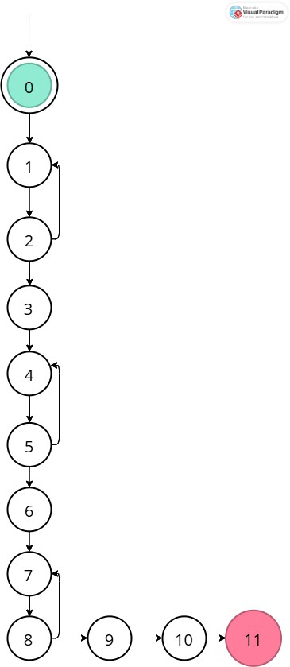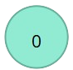

*Figure 3-1 EMI Calculator DFG*

|  |  |  |
| --- | --- | --- |
| **Variables** | **Definitions** | **Uses** |
| *val* | {2, 5, 8} | {(2, 1), (2, 3), (5, 4), (5, 6), (8, 7), (8, 9)} |
| *loanAmount* | {3} | {0} |
| *interestRate* | {6} | {10} |
| *loanTenure* | {9} | {10} |
| *amount* | {10} | {11} |

|  |  |
| --- | --- |
| **Variables** | **All DU Path Coverage** |
| *val* | [0,1,2,3,4,5,6,7,8,9,10,11],  [0,1,2,3,4,5,4,5,6,7,8,9,10,11],  [0,1,2,3,4,5,6,7,8,7,8,9,10,11] |
| *loanAmount* | [0,1,2,3,4,5,6,7,8,9,10,11] |
| *interestRate* | [0,1,2,3,4,5,6,7,8,9,10,11] |
| *loanTenure* | [0,1,2,3,4,5,6,7,8,9,10,11] |
| *amount* | [0,1,2,3,4,5,6,7,8,9,10,11] |

|  |  |
| --- | --- |
| **Variables** | **All Def Coverage** |
| *val* | [0,1,2,3,4,5,6,7,8,9,10,11],  [0,1,2,1,2,3,4,5,6,7,8,9,10,11],  [0,1,2,3,4,5,4,5,6,7,8,9,10,11],  [0,1,2,3,4,5,6,7,8,7,8,9,10,11],  [0,1,2,3,4,5,6,7,8,9,10,11] |
| *loanAmount* | [0,1,2,3,4,5,6,7,8,9,10,11] |
| *interestRate* | [0,1,2,3,4,5,6,7,8,9,10,11] |
| *loanTenure* | [0,1,2,3,4,5,6,7,8,9,10,11] |
| *amount* | [0,1,2,3,4,5,6,7,8,9,10,11] |

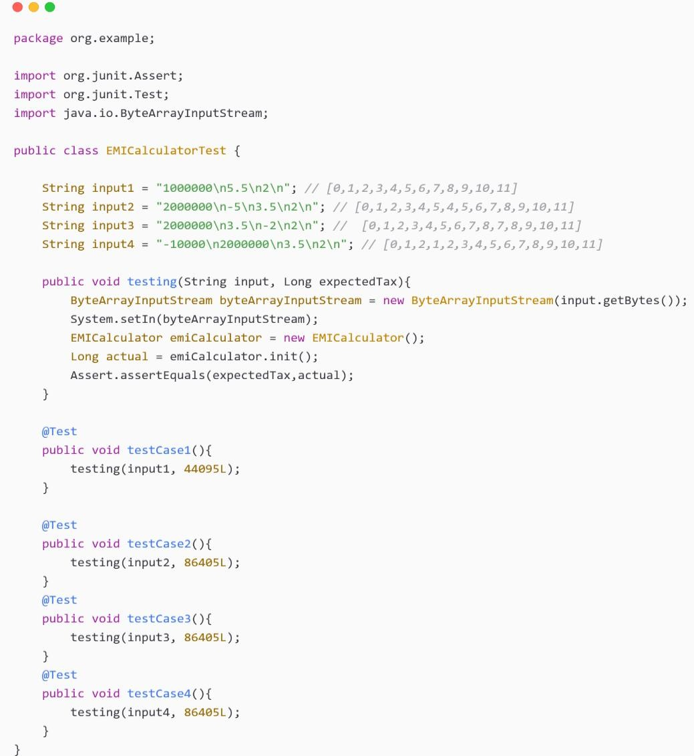

*Figure 3-2 EMI Calculator Test Code*

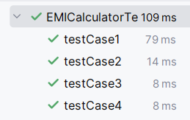

*Figure 3-3 EMI Calculator Test Cases*

### GRATUITY CALCULATOR

**Data Flow Graph:**

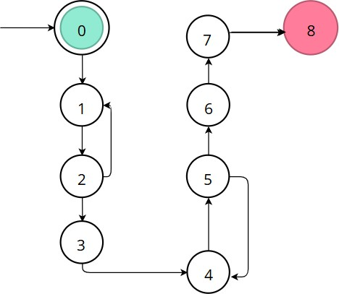

*Figure 3-4 GRATUITY Calculator DFG*

|  |  |  |
| --- | --- | --- |
| **Variables** | **Definitions** | **Uses** |
| ms | {2} | {(2, 1), (2, 3), 3} |
| monthlySalary | {3} | {7} |
| yos | {5} | {(5, 4), (5, 6), 6} |
| yearOfServices | {6} | {7} |
| amount | {7} | {8} |

|  |  |
| --- | --- |
| **Variables** | **All DU Path Coverage** |
| ms | [0,1,2,3,4,5,6,7,8],  [0,1,2,1,2,3,4,5,6,7,8] |
| monthlySalary | [0,1,2,3,4,5,6,7,8] |
| yos | [0,1,2,3,4,5,6,7,8],  [0,1,2,3,4,5,4,5,6,7,8] |
| yearOfServices | [0,1,2,3,4,5,6,7,8] |
| amount | [0,1,2,3,4,5,6,7,8] |

|  |  |
| --- | --- |
| **Variables** | **All Def Coverage** |
| ms | [0,1,2,3,4,5,6,7,8] |
| monthlySalary | [0,1,2,3,4,5,6,7,8] |
| yos | [0,1,2,3,4,5,6,7,8] |
| yearOfServices | [0,1,2,3,4,5,6,7,8] |
| amount | [0,1,2,3,4,5,6,7,8] |

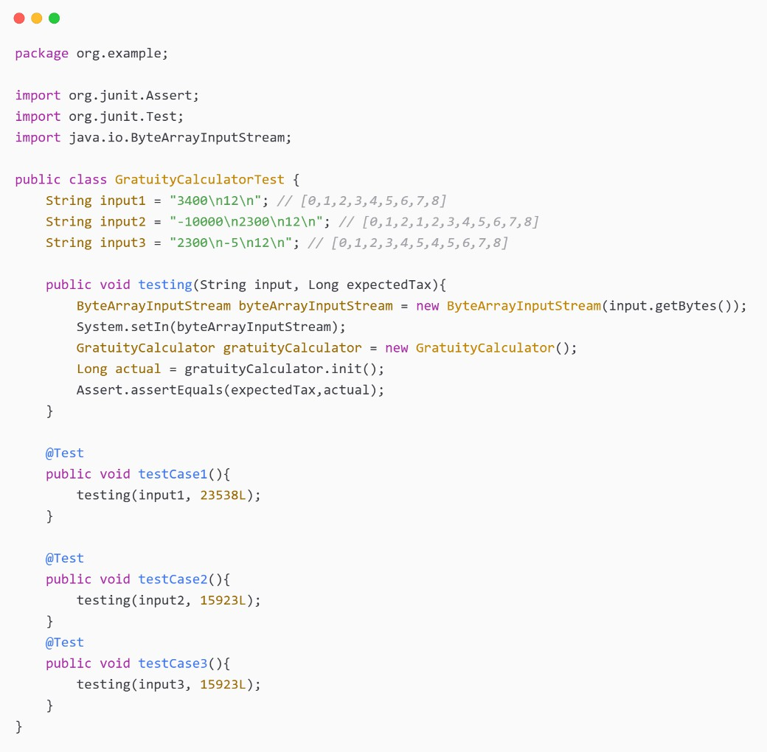

*Figure 3-5 GRATUITY Calculator Test Code*

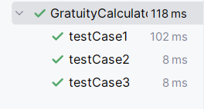

*Figure 3-6 GRATUITY Calculator Test Cases*

### LUMPSUM CALCULATOR

**Data Flow Graph:**

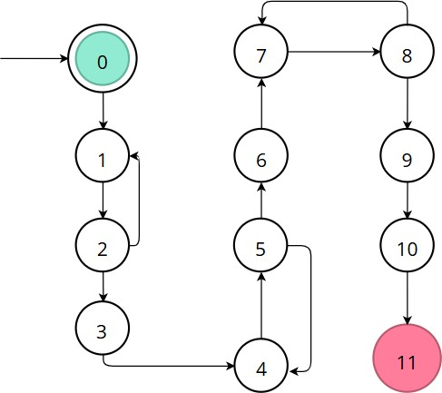

*Figure 3-7 LUMPSUM Calculator DFG*

|  |  |  |
| --- | --- | --- |
| **Variables** | **Definitions** | **Uses** |
| Val | {2, 5, 8} | {(2, 1), (2, 3), (5, 4), (5, 6), (8, 7), 9} |
| principleAmount | {3} | {10} |
| interestRate | {6} | {10} |
| timePeriod | {9} | {10} |
| amount | {10} | {11} |

|  |  |
| --- | --- |
| **Variables** | **All DU Path Coverage** |
| val | [0,1,2,3,4,5,6,7,8,9,10,11],  [0,1,2,3,4,5,4,5,6,7,8,9,10,11],  [0,1,2,3,4,5,6,7,8,7,8,9,10,11] |
| principleAmount | [0,1,2,3,4,5,6,7,8,9,10,11] |
| interestRate | [0,1,2,3,4,5,6,7,8,9,10,11] |
| timePeriod | [0,1,2,3,4,5,6,7,8,9,10,11] |
| amount | [0,1,2,3,4,5,6,7,8,9,10,11] |

|  |  |
| --- | --- |
| **Variables** | **All Def Coverage** |
| val | [0,1,2,3,4,5,6,7,8,9,10,11] |
| principleAmount | [0,1,2,3,4,5,6,7,8,9,10,11] |
| interestRate | [0,1,2,3,4,5,6,7,8,9,10,11] |
| timePeriod | [0,1,2,3,4,5,6,7,8,9,10,11] |
| amount | [0,1,2,3,4,5,6,7,8,9,10,11] |

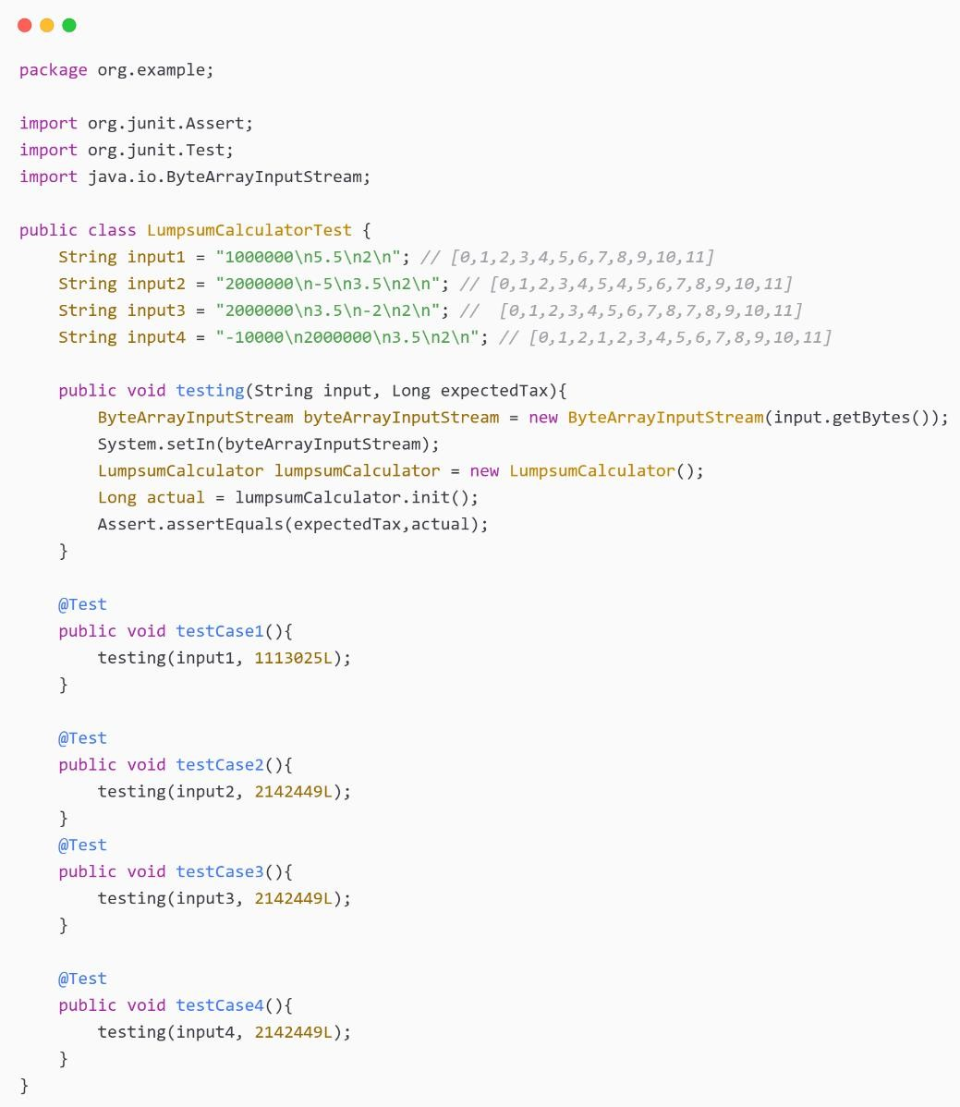

*Figure 3-8 GRATUITY Calculator Test Code*

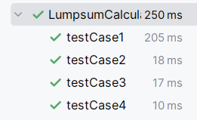

*Figure 3-9 GRATUITY Calculator Test Cases*

### PPF CALCULATOR

**Data Flow Graph:**

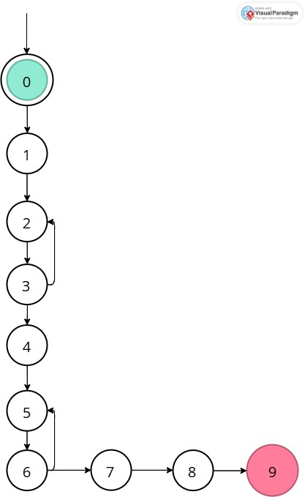

*Figure 3-10 PPF Calculator DFG*

|  |  |  |
| --- | --- | --- |
| **Variables** | **Definitions** | **Uses** |
| yi | {3} | {(3, 2), (3, 4), 4} |
| tp | {6} | {(6, 5), (6, 7), 7} |
| yearlyInvestment | {4} | {8} |
| timePeriod | {7} | {8} |
| rateOfInterest | {1} | {8} |
| amount | {8} | {9} |

|  |  |
| --- | --- |
| **Variables** | **All DU Path Coverage** |
| yi | [0,1,2,3,4,5,6,7,8,9],  [0,1,2,3,2,3,4,5,6,7,8,9] |
| tp | [0,1,2,3,4,5,6,7,8,9],  [0,1,2,3,4,5,6,5,6,7,8,9] |
| yearlyInvestment | [0,1,2,3,4,5,6,7,8,9] |
| timePeriod | [0,1,2,3,4,5,6,7,8,9] |
| rateOfInterest | [0,1,2,3,4,5,6,7,8,9] |
| amount | [0,1,2,3,4,5,6,7,8,9] |

|  |  |
| --- | --- |
| **Variables** | **All Def Coverage** |
| yi | [0,1,2,3,4,5,6,7,8,9] |
| tp | [0,1,2,3,4,5,6,7,8,9] |
| yearlyInvestment | [0,1,2,3,4,5,6,7,8,9] |
| timePeriod | [0,1,2,3,4,5,6,7,8,9] |
| rateOfInterest | [0,1,2,3,4,5,6,7,8,9] |
| amount | [0,1,2,3,4,5,6,7,8,9] |

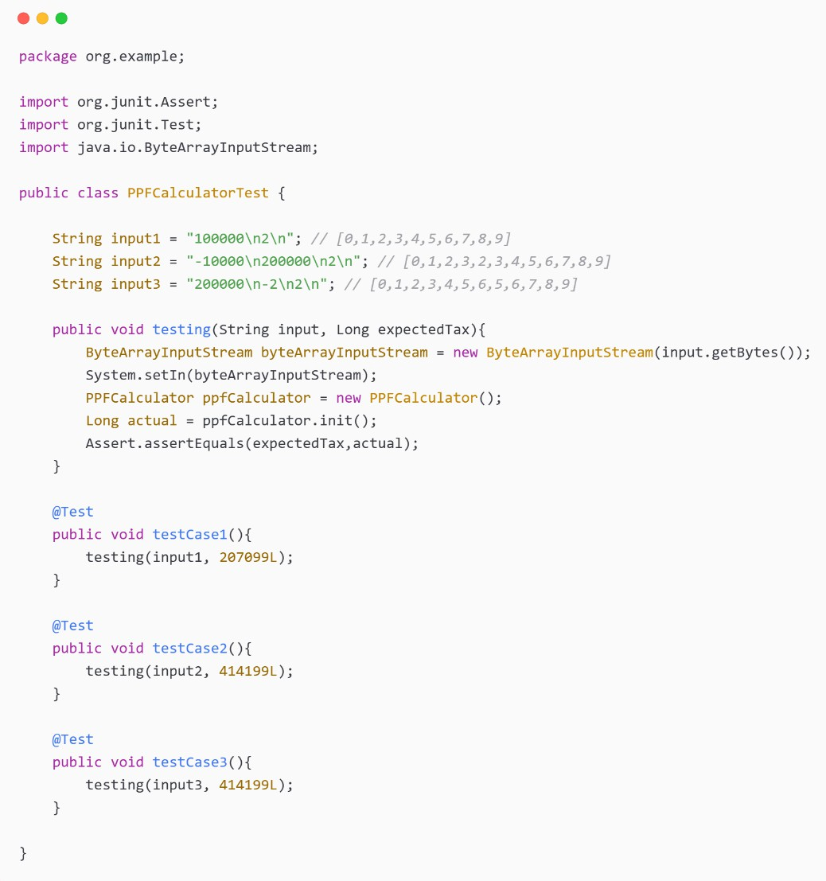

*Figure 3-11 PPF Calculator Test Code*

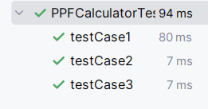

*Figure 3-12 PPF Calculator Test Cases*

### SIP CALCULATOR

**Data Flow Graph:**



*Figure 3-13 SIP Calculator DFG*

|  |  |  |
| --- | --- | --- |
| **Variable** | **Definitions** | **Uses** |
| val | {2, 5, 8} | {(2, 1), (2, 3), 3, (5, 4), (5, 6), 6,  (8, 7), (8, 9), 9} |
| monthlyInvestment | {3} | {10} |
| expectedReturnRateInPercentage | {6} | {10} |
| timePeriodInYear | {9} | {10} |
| amount | {10} | {11} |

|  |  |
| --- | --- |
| **Variable** | **All DU-Path Coverage** |
| Val | [0,1,2,3,4,5,6,7,8,9,10,11],  [0,1,2,1,2,3,4,5,6,7,8,9,10,11],  [0,1,2,3,4,5,4,5,6,7,8,9,10,11],  [0,1,2,3,4,5,6,7,8,7,8,9,10,11],  [0,1,2,3,4,5,6,7,8,9,10,11] |
| monthlyInvestment | [0, 1, 2, 3, 4, 5, 6, 7, 8, 9, 10, 11] |
| expectedReturnRateInPercentage | [0, 1, 2, 3, 4, 5, 6, 7, 8, 9, 10, 11] |
| timePeriodInYear | [0, 1, 2, 3, 4, 5, 6, 7, 8, 9, 10, 11] |
| Amount | [0, 1, 2, 3, 4, 5, 6, 7, 8, 9, 10, 11] |

|  |  |
| --- | --- |
| **Variable** | **All-Def Path Coverage** |
| val | [0,1,2,3,4,5,6,7,8,9,10,11],  [0,1,2,3,4,5,4,5,6,7,8,9,10,11],  [0,1,2,3,4,5,6,7,8,7,8,9,10,11] |
| monthlyInvestment | [0, 1, 2, 3, 4, 5, 6, 7, 8, 9, 10, 11] |
| expectedReturnRateInPercentage | [0, 1, 2, 3, 4, 5, 6, 7, 8, 9, 10, 11] |
| timePeriodInYear | [0, 1, 2, 3, 4, 5, 6, 7, 8, 9, 10, 11] |
| amount | [0, 1, 2, 3, 4, 5, 6, 7, 8, 9, 10, 11] |

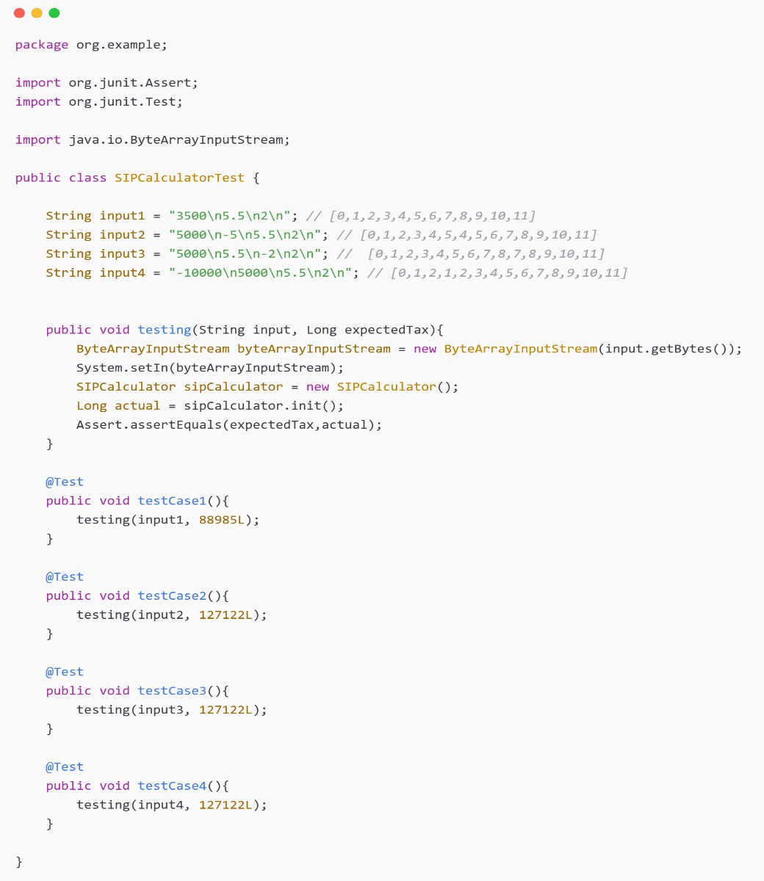

*Figure 3-14 SIP Calculator Test Code*

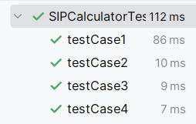

*Figure 3-15 SIP Calculator Test Cases*

### SWP CALCULATOR

**Data Flow Graph:**

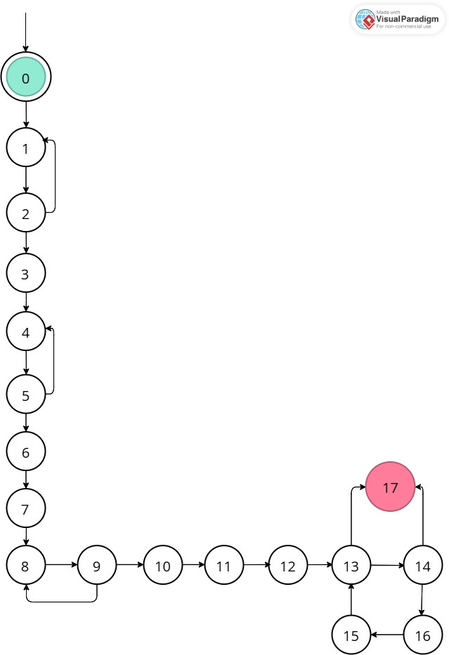

*Figure 3-16 SWP Calculator DFG*

|  |  |  |
| --- | --- | --- |
| **Variable** | **Definitions** | **Uses** |
| val | {2, 5, 7, 9} | {(2, 1), (2, 3), (5, 4), (5, 6), (6, 7), (9, 8), (9,  10), 10} |
| totalInvestment | {3} | {11} |
| withdrawalAmount | {6} | {11} |
| expectedReturnRate | {7} | {11} |
| timePeriod | {10} | {11} |
| deduct | {11} | {14} |
| val1 | {11, 14,  15} | {14, (14, 17), (14, 15), 15} |
| gain | {11, 15} | {15} |
| N | {11} | {(13, 14), (13, 17)} |
| I | {12, 16} | {(13, 14), (13, 17), 16} |
| returnAmnt | {17} | {17} |
| tmp | {15} | {15} |

|  |  |
| --- | --- |
| **Variable** | **All DU-Path Coverage** |
| val | [0,1,2,3,4,5,6,7,8,9,10,11,12,13,17],  [0,1,2,1,2,3,4,5,6,7,8,9,10,11,12,13,17],  [0,1,2,3,4,5,4,5,6,7,8,9,10,11,12,13,17],  [0,1,2,3,4,5,6,7,8,9,10,11,12,13,17],  [0,1,2,3,4,5,6,7,8,9,8,9,10,11,12,13,17] |
| totalInvestment | [0, 1, 2, 3, 4, 5, 6, 7, 8, 9, 10, 11, 12, 13, 17] |
| withdrawalAmount | [0, 1, 2, 3, 4, 5, 6, 7, 8, 9, 10, 11, 12, 13, 17] |
| expectedReturnRate | [0, 1, 2, 3, 4, 5, 6, 7, 8, 9, 10, 11, 12, 13, 17] |
| timePeriod | [0, 1, 2, 3, 4, 5, 6, 7, 8, 9, 10, 11, 12, 13, 17] |
| deduct | [0, 1, 2, 3, 4, 5, 6, 7, 8, 9, 10, 11, 12, 13, 14, 17] |
| val1 | [0,1,2,3,4,5,6,7,8,9,10,11,12,13,14,17],  [0,1,2,3,4,5,6,7,8,9,10,11,12,13,14,15,16,13,17],  [0,1,2,3,4,5,6,7,8,9,10,11,12,13,14,15,16,13,14,17] |
| gain | [0,1,2,3,4,5,6,7,8,9,10,11,12,13,14,15,16,13,17],  [0,1,2,3,4,5,6,7,8,9,10,11,12,13,14,15,16,13,14,15,  16,13,17] |
| n | [0,1,2,3,4,5,6,7,8,9,10,11,12,13,14,17],  [0,1,2,3,4,5,6,7,8,9,10,11,12,13,17] |
| i | [0,1,2,3,4,5,6,7,8,9,10,11,12,13,14,17],  [0,1,2,3,4,5,6,7,8,9,10,11,12,13,17],  [0,1,2,3,4,5,6,7,8,9,10,11,12,13,14,15,16,13,17],  [0,1,2,3,4,5,6,7,8,9,10,11,12,13,14,15,16,13,14,17],  [0,1,2,3,4,5,6,7,8,9,10,11,12,13,14,15,16,13,14,15,  16,13,17] |
| returnAmnt | No Path Needed |
| tmp | [0,1,2,3,4,5,6,7,8,9,10,11,12,13,14,15,16,13,14,15,  16,13,17] |

|  |  |
| --- | --- |
| **Variable** | **All-Def Path Coverage** |
| val | [0,1,2,3,4,5,6,7,8,9,10,11,12,13,17],  [0,1,2,3,4,5,4,5,6,7,8,9,10,11,12,13,17],  [0,1,2,3,4,5,6,7,8,9,8,9,10,11,12,13,17] |
| totalInvestment | [0, 1, 2, 3, 4, 5, 6, 7, 8, 9, 10, 11, 12, 13, 17] |
| withdrawalAmount | [0, 1, 2, 3, 4, 5, 6, 7, 8, 9, 10, 11, 12, 13, 17] |
| expectedReturnRate | [0, 1, 2, 3, 4, 5, 6, 7, 8, 9, 10, 11, 12, 13, 17] |
| timePeriod | [0, 1, 2, 3, 4, 5, 6, 7, 8, 9, 10, 11, 12, 13, 17] |
| deduct | [0, 1, 2, 3, 4, 5, 6, 7, 8, 9, 10, 11, 12, 13, 14, 17] |
| val1 | [0,1,2,3,4,5,6,7,8,9,10,11,12,13,14,17],  [0,1,2,3,4,5,6,7,8,9,10,11,12,13,14,15,16,13,17],  [0,1,2,3,4,5,6,7,8,9,10,11,12,13,14,15,16,13,14,17] |
| gain | [0,1,2,3,4,5,6,7,8,9,10,11,12,13,14,15,16,13,17],  [0,1,2,3,4,5,6,7,8,9,10,11,12,13,14,15,16,13,14,15,  16,13,17] |
| n | [0, 1, 2, 3, 4, 5, 6, 7, 8, 9, 10, 11, 12, 13, 14, 15, 16, 17] |
| i | [0,1,2,3,4,5,6,7,8,9,10,11,12,13,14,17],  [0,1,2,3,4,5,6,7,8,9,10,11,12,13,14,15,16,13,14,17] |
| returnAmnt | No Path Needed |
| tmp | [0,1,2,3,4,5,6,7,8,9,10,11,12,13,14,15,16,13,14,15,  16,13,17] |

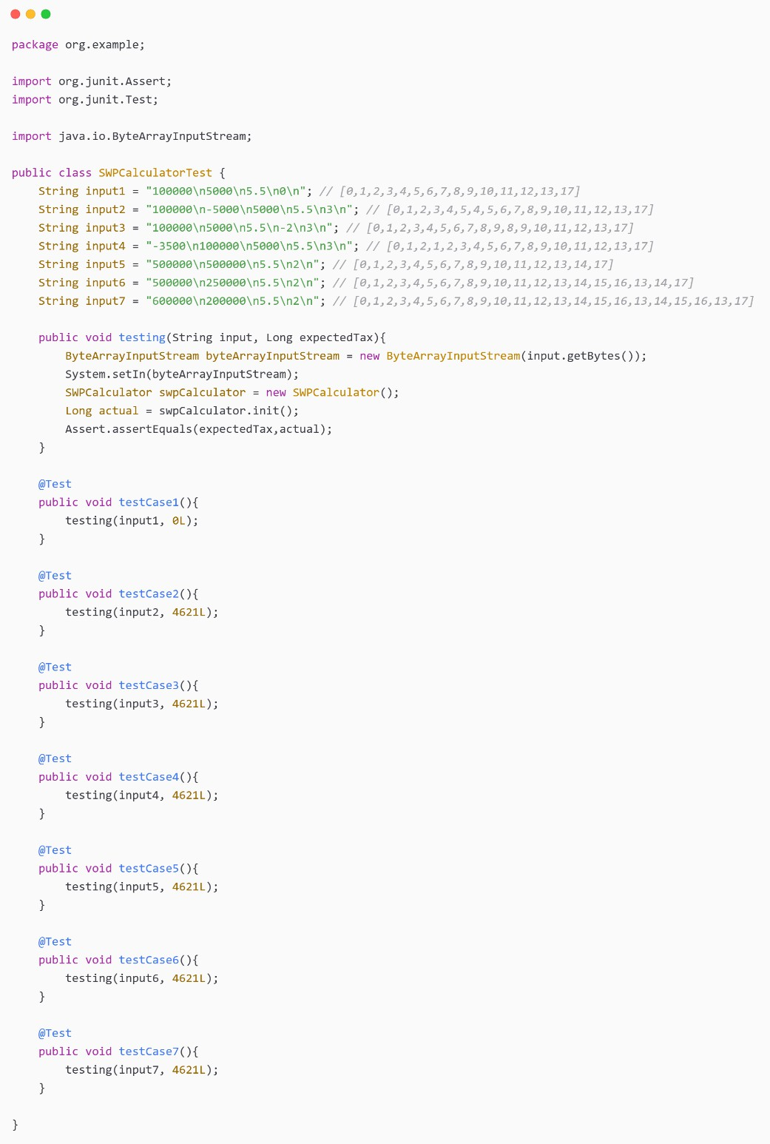

*Figure 3-17 SWP Calculator Test Code*

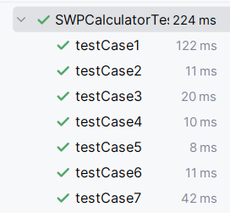

*Figure 3-18 SWP Calculator Test Cases*

### TAX CALCULATOR

**Data Flow Graph:**

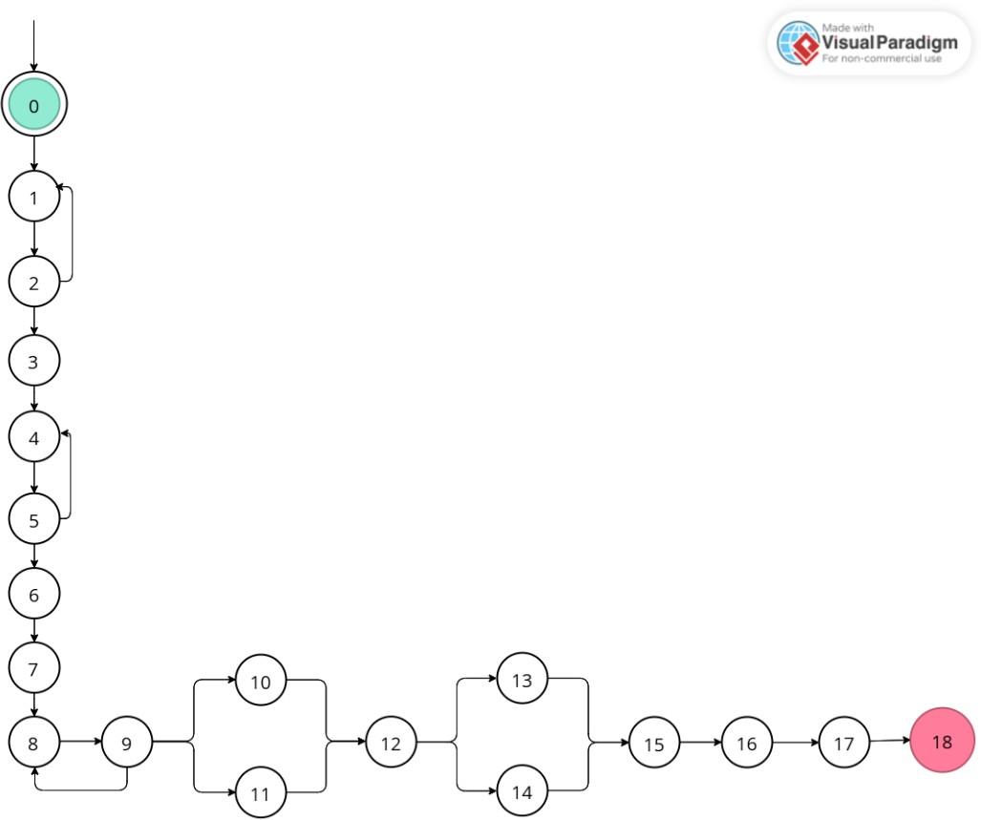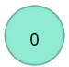

*Figure 3-19 GRATUITY Calculator DFG*

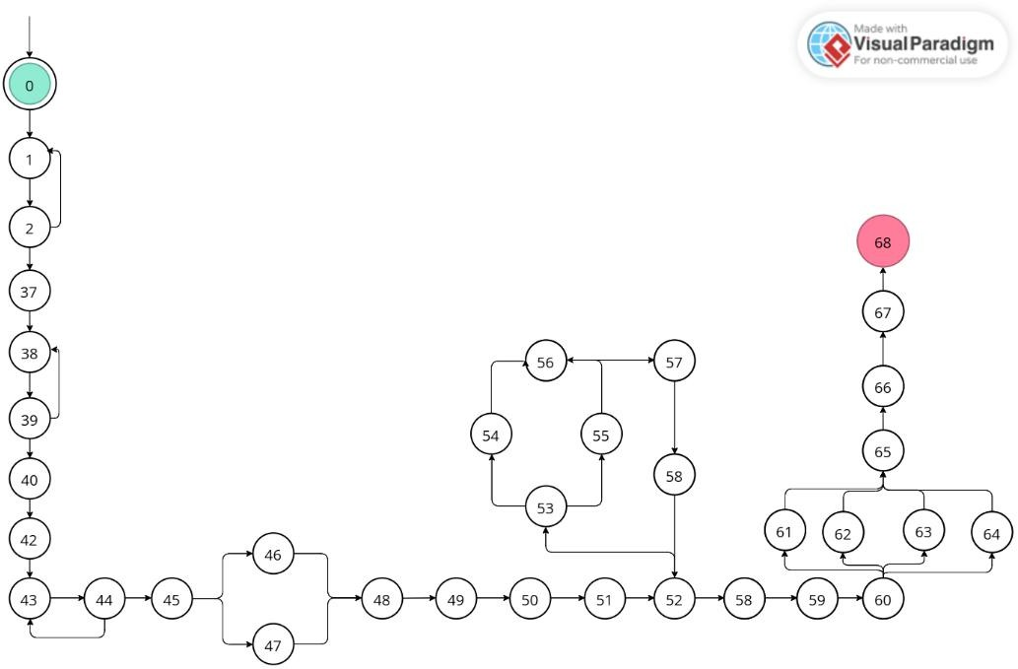

*Figure 3-20 GRATUITY Calculator DFG*

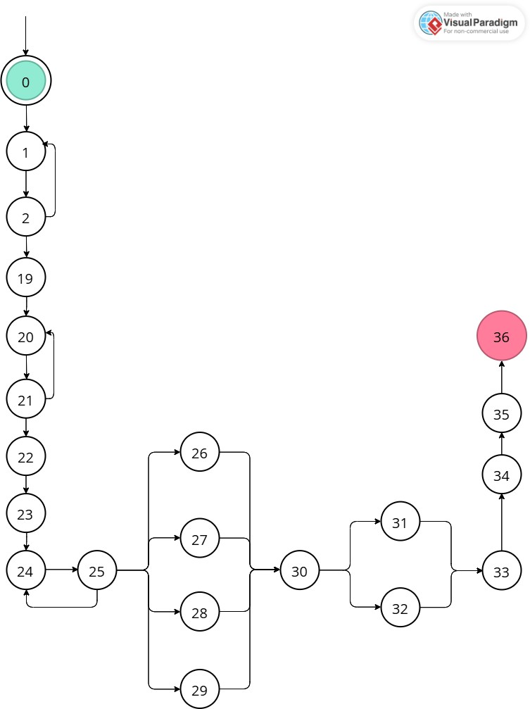

*Figure 3-21 GRATUITY Calculator DFG*

|  |  |  |
| --- | --- | --- |
| **Variable** | **Definitions** | **Uses** |
| slabs | {1} | {(52, 52), (53, 64), (53, 55),  (56)} |
| slab | {1} | {51} |
| type | {2} | {(2, 1), (2, 3), (2, 19), (2, 37)} |
| income | {3, 19, 44} | {4, 7, 20, 23, 50} |
| ngoDonation | {4, 20} | {5, 21} |
| goDonation | {4, 20} | {5, 21} |
| netQualifyingLimit | {5, 21} | {5, 21} |
| deduction | {5, 21, 48} | {6, 22, 49} |
| deductedAmt | {5, 22, 49} | {7, 23, 50} |
| taxableAmt | {7, 23, 50, 57} | {10, 11, (12,13), (12,14), 26, 27,  28, 29, (30,31), (30,32), (52,53),  54, 55, 57, (60,61), (60,62),  (60,63), (60,64)} |
| id | {9, 25} | {(9,8), (9,10), (9,11), (25,24),  (25,26), (25,27), (25,28),  (25,29)} |
| ta | {10, 11, 26, 27,  28, 29, 56} | {12, 30, 56, 59} |
| taxAmt | {12, 30, 59} | { 13, 14, 16, 18, 31, 32, 34, 36,  61, 62, 63, 64, 66, 68 } |
| sc | {13, 14, 61, 62,  63, 64, 31, 32} | {15, 33, 65} |
| surcharge | {15, 33, 65} | {18, 36, 68} |
| charge | {16, 34, 60} | {17, 35, 67} |
| healthAndEduCess | {17, 35, 67} | {18, 36, 68} |
| netTax | {18, 36, 68} | {} |
| schemeID | {39} | {(39, 38), 40} |
| regimeID | {40} | {(41, 42), (45, 46), (41, 43), (45,  47)} |
| ageGrp | {40, 42} | {(42, 41), 43} |
| ageGrpID | {43} | {51} |
| 80c | {45, 46} | {48} |
| 80ccd1b | {45, 46, 47} | {48} |
| i | {51, 58} | {(52,53), (52,59), (53,54),  (53,55), 55, 56, 58} |
| minA | {54, 55} | {56, 57} |

|  |  |
| --- | --- |
| **Variable** | **All DU-Path Coverage** |
| slabs | {  [0, 1, 2, 37, 38, 39, 40, 41, 42, 43, 44, 45, 46, 48, 49, 50, 51,  52, 53, 54, 56, 57, 58, 52, 59, 60, 61, 65, 66, 67, 68],  [0, 1, 2, 37, 38, 39, 40, 41, 42, 43, 44, 45, 47, 48, 49, 50, 51,  52, 53, 54, 56, 57, 58, 52, 59, 60, 61, 65, 66, 67, 68]  } |
| slab | {  [0, 1, 2, 37, 38, 39, 40, 41, 42, 43, 44, 45, 46, 48, 49, 50, 51,  52, 53, 54, 56, 57, 58, 52, 59, 60, 61, 65, 66, 67, 68],  [0, 1, 2, 37, 38, 39, 40, 41, 42, 43, 44, 45, 47, 48, 49, 50, 51,  52, 53, 54, 56, 57, 58, 52, 59, 60, 61, 65, 66, 67, 68]  } |
| type | {  [0, 1, 2, 37, 38, 39, 40, 41, 42, 43, 44, 45, 46, 48, 49, 50, 51,  52, 53, 54, 56, 57, 58, 52, 59, 60, 61, 65, 66, 67, 68],  [0, 1, 2],  [0, 1, 2, 1, 2, 3, 4, 5, 6, 7, 8, 9, 10, 12, 13, 15, 16, 17, 18],  [0, 1, 2, 19, 20, 21, 22, 23, 24, 25, 26, 30, 31, 33, 34, 35, 36]  } |
| income | {  [0, 1, 2, 1, 2, 3, 4, 5, 6, 7, 8, 9, 10, 12, 13, 15, 16, 17, 18],  [0, 1, 2, 19, 20, 21, 22, 23, 24, 25, 26, 30, 31, 33, 34, 35, 36],  [0, 1, 2, 37, 38, 39, 40, 41, 42, 43, 44, 45, 46, 48, 49, 50, 51,  52, 53, 54, 56, 57, 58, 52, 59, 60, 61, 65, 66, 67, 68],  [0, 1, 2, 37, 38, 39, 40, 41, 42, 43, 44, 45, 47, 48, 49, 50, 51,  52, 53, 54, 56, 57, 58, 52, 59, 60, 61, 65, 66, 67, 68]  } |
| ngoDonation | {  [0, 1, 2, 1, 2, 3, 4, 5, 6, 7, 8, 9, 10, 12, 13, 15, 16, 17, 18],  [0, 1, 2, 19, 20, 21, 22, 23, 24, 25, 26, 30, 31, 33, 34, 35, 36]  } |
| goDonation | {  [0, 1, 2, 1, 2, 3, 4, 5, 6, 7, 8, 9, 10, 12, 13, 15, 16, 17, 18],  [0, 1, 2, 19, 20, 21, 22, 23, 24, 25, 26, 30, 31, 33, 34, 35, 36]  } |
| netQualifyingLimit | {  [0, 1, 2, 1, 2, 3, 4, 5, 6, 7, 8, 9, 10, 12, 13, 15, 16, 17, 18],  [0, 1, 2, 19, 20, 21, 22, 23, 24, 25, 26, 30, 31, 33, 34, 35, 36]  } |
| deduction | {  [0, 1, 2, 1, 2, 3, 4, 5, 6, 7, 8, 9, 10, 12, 13, 15, 16, 17, 18],  [0, 1, 2, 19, 20, 21, 22, 23, 24, 25, 26, 30, 31, 33, 34, 35, 36],  [0, 1, 2, 37, 38, 39, 40, 41, 42, 43, 44, 45, 46, 48, 49, 50, 51,  52, 53, 54, 56, 57, 58, 52, 59, 60, 61, 65, 66, 67, 68]  } |

|  |  |
| --- | --- |
| deductedAmt | {  [0, 1, 2, 1, 2, 3, 4, 5, 6, 7, 8, 9, 10, 12, 13, 15, 16, 17, 18],  [0, 1, 2, 19, 20, 21, 22, 23, 24, 25, 26, 30, 31, 33, 34, 35, 36],  [0, 1, 2, 37, 38, 39, 40, 41, 42, 43, 44, 45, 46, 48, 49, 50, 51,  52, 53, 54, 56, 57, 58, 52, 59, 60, 61, 65, 66, 67, 68]  } |
| taxableAmt | {  [0, 1, 2, 1, 2, 3, 4, 5, 6, 7, 8, 9, 11, 12, 13, 15, 16, 17, 18],  [0, 1, 2, 1, 2, 3, 4, 5, 6, 7, 8, 9, 10, 12, 13, 15, 16, 17, 18],  [0, 1, 2, 1, 2, 3, 4, 5, 6, 7, 8, 9, 11, 12, 14, 15, 16, 17, 18],  [0, 1, 2, 1, 2, 3, 4, 5, 6, 7, 8, 9, 10, 12, 14, 15, 16, 17, 18],  [0, 1, 2, 19, 20, 21, 22, 23, 24, 25, 26, 30, 31, 33, 34, 35, 36],  [0, 1, 2, 19, 20, 21, 22, 23, 24, 25, 26, 30, 32, 33, 34, 35, 36],  [0, 1, 2, 19, 20, 21, 22, 23, 24, 25, 27, 30, 32, 33, 34, 35, 36],  [0, 1, 2, 19, 20, 21, 22, 23, 24, 25, 27, 30, 31, 33, 34, 35, 36],  [0, 1, 2, 19, 20, 21, 22, 23, 24, 25, 28, 30, 32, 33, 34, 35, 36],  [0, 1, 2, 19, 20, 21, 22, 23, 24, 25, 28, 30, 31, 33, 34, 35, 36],  [0, 1, 2, 19, 20, 21, 22, 23, 24, 25, 29, 30, 32, 33, 34, 35, 36],  [0, 1, 2, 19, 20, 21, 22, 23, 24, 25, 29, 30, 31, 33, 34, 35, 36],  [0, 1, 2, 37, 38, 39, 40, 41, 42, 43, 44, 45, 46, 48, 49, 50, 51,  52, 53, 54, 56, 57, 58, 52, 53, 54, 56, 57, 58, 52, 59, 60, 61, 65,  66, 67, 68],  [0, 1, 2, 37, 38, 39, 40, 41, 42, 43, 44, 45, 46, 48, 49, 50, 51,  52, 53, 55, 56, 57, 58, 52, 53, 54, 56, 57, 58, 52, 59, 60, 62, 65,  66, 67, 68],  [0, 1, 2, 37, 38, 39, 40, 41, 42, 43, 44, 45, 46, 48, 49, 50, 51,  52, 53, 55, 56, 57, 58, 52, 53, 54],  [0, 1, 2, 37, 38, 39, 40, 41, 42, 43, 44, 45, 46, 48, 49, 50, 51,  52, 59, 60, 64, 65, 66, 67, 68],  [0, 1, 2, 37, 38, 39, 40, 41, 42, 43, 44, 45, 46, 48, 49, 50, 51,  52, 59, 60, 63, 65, 66, 67, 68],  [0, 1, 2, 37, 38, 39, 40, 41, 42, 43, 44, 45, 46, 48, 49, 50, 51,  52, 59, 60, 62, 65, 66, 67, 68],  [0, 1, 2, 37, 38, 39, 40, 41, 42, 43, 44, 45, 46, 48, 49, 50, 51,  52, 59, 60, 61, 65, 66, 67, 68]  } |
| id | {  [0, 1, 2, 3, 4, 5, 6, 7, 8, 9, 8, 9, 10, 12, 13, 15, 16, 17, 18],  [0, 1, 2, 3, 4, 5, 6, 7, 8, 9, 11, 12, 13, 15, 16, 17, 18],  [0, 1, 2, 19, 20, 21, 22, 23, 24, 25, 24, 25, 26, 30, 31, 33, 34,  35, 36],  [0, 1, 2, 19, 20, 21, 22, 23, 24, 25, 27, 30, 31, 33, 34, 35, 36],  [0, 1, 2, 19, 20, 21, 22, 23, 24, 25, 28, 30, 31, 33, 34, 35, 36],  [0, 1, 2, 19, 20, 21, 22, 23, 24, 25, 29, 30, 31, 33, 34, 35, 36]  } |

|  |  |
| --- | --- |
| ta | {  [0, 1, 2, 1, 2, 3, 4, 5, 6, 7, 8, 9, 11, 12, 13, 15, 16, 17, 18],  [0, 1, 2, 1, 2, 3, 4, 5, 6, 7, 8, 9, 10, 12, 13, 15, 16, 17, 18],  [0, 1, 2, 19, 20, 21, 22, 23, 24, 25, 24, 25, 26, 30, 31, 33, 34,  35, 36],  [0, 1, 2, 19, 20, 21, 22, 23, 24, 25, 27, 30, 31, 33, 34, 35, 36],  [0, 1, 2, 19, 20, 21, 22, 23, 24, 25, 28, 30, 31, 33, 34, 35, 36],  [0, 1, 2, 19, 20, 21, 22, 23, 24, 25, 29, 30, 31, 33, 34, 35, 36],  [0, 1, 2, 37, 38, 39, 40, 41, 42, 43, 44, 45, 46, 48, 49, 50, 51,  52, 53, 55, 56, 57, 58, 52, 53, 54, 56, 57, 58, 52, 59, 60, 64, 65,  66, 67, 68],  [0, 1, 2, 37, 38, 39, 40, 41, 42, 43, 44, 45, 46, 48, 49, 50, 51,  52, 53, 55, 56, 57, 58, 52, 53, 55, 56, 57, 58, 52, 59, 60, 64, 65,  66, 67, 68]  } |
| taxAmt | {  [0, 1, 2, 1, 2, 3, 4, 5, 6, 7, 8, 9, 11, 12, 13, 15, 16, 17, 18],  [0, 1, 2, 1, 2, 3, 4, 5, 6, 7, 8, 9, 11, 12, 14, 15, 16, 17, 18],  [0, 1, 2, 19, 20, 21, 22, 23, 24, 25, 24, 25, 26, 30, 31, 33, 34,  35, 36],  [0, 1, 2, 19, 20, 21, 22, 23, 24, 25, 24, 25, 26, 30, 32, 33, 34,  35, 36],  [0, 1, 2, 37, 38, 39, 40, 41, 42, 43, 44, 45, 46, 48, 49, 50, 51,  52, 53, 55, 56, 57, 58, 52, 53, 54, 56, 57, 58, 52, 59, 60, 61, 65,  66, 67, 68],  [0, 1, 2, 37, 38, 39, 40, 41, 42, 43, 44, 45, 46, 48, 49, 50, 51,  52, 53, 55, 56, 57, 58, 52, 53, 54, 56, 57, 58, 52, 59, 60, 62, 65,  66, 67, 68],  [0, 1, 2, 37, 38, 39, 40, 41, 42, 43, 44, 45, 46, 48, 49, 50, 51,  52, 53, 55, 56, 57, 58, 52, 53, 54, 56, 57, 58, 52, 59, 60, 63, 65,  66, 67, 68],  [0, 1, 2, 37, 38, 39, 40, 41, 42, 43, 44, 45, 46, 48, 49, 50, 51,  52, 53, 55, 56, 57, 58, 52, 53, 54, 56, 57, 58, 52, 59, 60, 64, 65,  66, 67, 68]} |
| sc | {[0, 1, 2, 1, 2, 3, 4, 5, 6, 7, 8, 9, 11, 12, 13, 15, 16, 17, 18],  [0, 1, 2, 1, 2, 3, 4, 5, 6, 7, 8, 9, 11, 12, 14, 15, 16, 17, 18],  [0, 1, 2, 19, 20, 21, 22, 23, 24, 25, 24, 25, 26, 30, 31, 33, 34,  35, 36],  [0, 1, 2, 19, 20, 21, 22, 23, 24, 25, 24, 25, 26, 30, 32, 33, 34,  35, 36],  [0, 1, 2, 37, 38, 39, 40, 41, 42, 43, 44, 45, 46, 48, 49, 50, 51,  52, 53, 55, 56, 57, 58, 52, 53, 54, 56, 57, 58, 52, 59, 60, 61, 65,  66, 67, 68],  [0, 1, 2, 37, 38, 39, 40, 41, 42, 43, 44, 45, 46, 48, 49, 50, 51,  52, 53, 55, 56, 57, 58, 52, 53, 54, 56, 57, 58, 52, 59, 60, 62, 65,  66, 67, 68],  [0, 1, 2, 37, 38, 39, 40, 41, 42, 43, 44, 45, 46, 48, 49, 50, 51,  52, 53, 55, 56, 57, 58, 52, 53, 54, 56, 57, 58, 52, 59, 60, 63, 65,  66, 67, 68],  [0, 1, 2, 37, 38, 39, 40, 41, 42, 43, 44, 45, 46, 48, 49, 50, 51,  52, 53, 55, 56, 57, 58, 52, 53, 54, 56, 57, 58, 52, 59, 60, 64, 65,  66, 67, 68]} |

|  |  |
| --- | --- |
| surcharge | {  [0, 1, 2, 1, 2, 3, 4, 5, 6, 7, 8, 9, 11, 12, 13, 15, 16, 17, 18],  [0, 1, 2, 19, 20, 21, 22, 23, 24, 25, 24, 25, 26, 30, 32, 33, 34,  35, 36],  [0, 1, 2, 37, 38, 39, 40, 41, 42, 43, 44, 45, 46, 48, 49, 50, 51,  52, 53, 55, 56, 57, 58, 52, 53, 54, 56, 57, 58, 52, 59, 60, 64, 65,  66, 67, 68]} |
| charge | {  [0, 1, 2, 1, 2, 3, 4, 5, 6, 7, 8, 9, 11, 12, 13, 15, 16, 17, 18],  [0, 1, 2, 19, 20, 21, 22, 23, 24, 25, 24, 25, 26, 30, 32, 33, 34,  35, 36],  [0, 1, 2, 37, 38, 39, 40, 41, 42, 43, 44, 45, 46, 48, 49, 50, 51,  52, 53, 55, 56, 57, 58, 52, 53, 54, 56, 57, 58, 52, 59, 60, 64, 65,  66, 67, 68]  } |
| healthAndEduCess | {  [0, 1, 2, 1, 2, 3, 4, 5, 6, 7, 8, 9, 11, 12, 13, 15, 16, 17, 18],  [0, 1, 2, 19, 20, 21, 22, 23, 24, 25, 24, 25, 26, 30, 32, 33, 34,  35, 36],  [0, 1, 2, 37, 38, 39, 40, 41, 42, 43, 44, 45, 46, 48, 49, 50, 51,  52, 53, 55, 56, 57, 58, 52, 53, 54, 56, 57, 58, 52, 59, 60, 64, 65,  66, 67, 68]  } |
| netTax | {  [0, 1, 2, 1, 2, 3, 4, 5, 6, 7, 8, 9, 11, 12, 13, 15, 16, 17, 18],  [0, 1, 2, 19, 20, 21, 22, 23, 24, 25, 24, 25, 26, 30, 32, 33, 34,  35, 36],  [0, 1, 2, 37, 38, 39, 40, 41, 42, 43, 44, 45, 46, 48, 49, 50, 51,  52, 53, 55, 56, 57, 58, 52, 53, 54, 56, 57, 58, 52, 59, 60, 64, 65,  66, 67, 68]  } |
| schemeID | {  [0, 1, 2, 37, 38, 39, 38, 39, 40, 41, 42, 43, 44, 45, 46, 48, 49,  50, 51, 52, 53, 55, 56, 57, 58, 52, 53, 54, 56, 57, 58, 52, 59, 60,  64, 65, 66, 67, 68]  } |
| regimeID | {  [0, 1, 2, 37, 38, 39, 40, 41, 42, 43, 44, 45, 46, 48, 49, 50, 51,  52, 53, 55, 56, 57, 58, 52, 53, 54, 56, 57, 58, 52, 59, 60, 64, 65,  66, 67, 68],  [0, 1, 2, 37, 38, 39, 40, 41, 43, 44, 45, 47, 48, 49, 50, 51, 52,  53, 55, 56, 57, 58, 52, 53, 54, 56, 57, 58, 52, 59, 60, 64, 65, 66,  67, 68]  } |
| ageGrp | {  [0, 1, 2, 37, 38, 39, 40, 41, 42, 41, 42, 43, 44, 45, 46, 48, 49,  50, 51, 52, 53, 55, 56, 57, 58, 52, 53, 54, 56, 57, 58, 52, 59, 60,  64, 65, 66, 67, 68],  [0, 1, 2, 37, 38, 39, 40, 41, 43, 44, 45, 47, 48, 49, 50, 51, 52,  53, 55, 56, 57, 58, 52, 53, 54, 56, 57, 58, 52, 59, 60, 64, 65, 66,  67, 68]} |

|  |  |
| --- | --- |
| ageGrpID | {  [0, 1, 2, 37, 38, 39, 40, 41, 42, 43, 44, 45, 46, 48, 49, 50, 51,  52, 53, 55, 56, 57, 58, 52, 53, 54, 56, 57, 58, 52, 59, 60, 64, 65,  66, 67, 68],  [0, 1, 2, 37, 38, 39, 40, 41, 42, 43, 44, 45, 47, 48, 49, 50, 51,  52, 53, 55, 56, 57, 58, 52, 53, 54, 56, 57, 58, 52, 59, 60, 64, 65,  66, 67, 68]  } |
| 80c | [0, 1, 2, 37, 38, 39, 40, 41, 42, 43, 44, 45, 46, 48, 49, 50, 51,  52, 53, 55, 56, 57, 58, 52, 53, 54, 56, 57, 58, 52, 59, 60, 64, 65,  66, 67, 68] |
| 80ccd1b | {  [0, 1, 2, 37, 38, 39, 40, 41, 42, 43, 44, 45, 46, 48, 49, 50, 51,  52, 53, 55, 56, 57, 58, 52, 53, 54, 56, 57, 58, 52, 59, 60, 64, 65,  66, 67, 68],  [0, 1, 2, 37, 38, 39, 40, 41, 42, 43, 44, 45, 47, 48, 49, 50, 51,  52, 53, 55, 56, 57, 58, 52, 53, 54, 56, 57, 58, 52, 59, 60, 64, 65,  66, 67, 68]  } |
| i | {  [0, 1, 2, 37, 38, 39, 40, 41, 42, 43, 44, 45, 46, 48, 49, 50, 51,  52, 53, 55, 56, 57, 58, 52, 53, 55, 56, 57, 58, 52, 59, 60, 64, 65,  66, 67, 68],  [0, 1, 2, 37, 38, 39, 40, 41, 42, 43, 44, 45, 46, 48, 49, 50, 51,  52, 59, 60, 64, 65, 66, 67, 68],  [0, 1, 2, 37, 38, 39, 40, 41, 42, 43, 44, 45, 46, 48, 49, 50, 51,  52, 53, 54, 56, 57, 58, 52, 53, 54, 56, 57, 58, 52, 59, 60, 64, 65,  66, 67, 68]  } |
| minA | {  [0, 1, 2, 37, 38, 39, 40, 41, 42, 43, 44, 45, 46, 48, 49, 50, 51,  52, 53, 54, 56, 57, 58, 52, 53, 55, 56, 57, 58, 52, 59, 60, 64, 65,  66, 67, 68]  } |

|  |  |
| --- | --- |
| **Variable** | **All Def Coverage** |
| slabs | {  [0, 1, 2, 37, 38, 39, 40, 41, 42, 43, 44, 45, 46, 48, 49, 50, 51,  52, 53, 54, 56, 57, 58, 52, 59, 60, 61, 65, 66, 67, 68],  [0, 1, 2, 37, 38, 39, 40, 41, 42, 43, 44, 45, 46, 48, 49, 50, 51,  52, 53, 55, 56, 57, 58, 52, 59, 60, 61, 65, 66, 67, 68]  } |
| slab | {  [0, 1, 2, 37, 38, 39, 40, 41, 42, 43, 44, 45, 46, 48, 49, 50, 51,  52, 53, 54, 56, 57, 58, 52, 59, 60, 61, 65, 66, 67, 68]  } |
| type | {  [0, 1, 2, 37, 38, 39, 40, 41, 42, 43, 44, 45, 46, 48, 49, 50, 51,  52, 53, 54, 56, 57, 58, 52, 59, 60, 61, 65, 66, 67, 68]  } |
| income | {  [0, 1, 2, 1, 2, 3, 4, 5, 6, 7, 8, 9, 10, 12, 13, 15, 16, 17, 18],  [0, 1, 2, 19, 20, 21, 22, 23, 24, 25, 26, 30, 31, 33, 34, 35, 36],  [0, 1, 2, 37, 38, 39, 40, 41, 42, 43, 44, 45, 46, 48, 49, 50, 51,  52, 53, 54, 56, 57, 58, 52, 59, 60, 61, 65, 66, 67, 68]  } |
| ngoDonation | {  [0, 1, 2, 1, 2, 3, 4, 5, 6, 7, 8, 9, 10, 12, 13, 15, 16, 17, 18],  [0, 1, 2, 19, 20, 21, 22, 23, 24, 25, 26, 30, 31, 33, 34, 35, 36]  } |
| goDonation | {  [0, 1, 2, 1, 2, 3, 4, 5, 6, 7, 8, 9, 10, 12, 13, 15, 16, 17, 18],  [0, 1, 2, 19, 20, 21, 22, 23, 24, 25, 26, 30, 31, 33, 34, 35, 36]  } |
| netQualifyingLimit | {  [0, 1, 2, 1, 2, 3, 4, 5, 6, 7, 8, 9, 10, 12, 13, 15, 16, 17, 18],  [0, 1, 2, 19, 20, 21, 22, 23, 24, 25, 26, 30, 31, 33, 34, 35, 36],  [0, 1, 2, 37, 38, 39, 40, 41, 42, 43, 44, 45, 46, 48, 49, 50, 51,  52, 53, 54, 56, 57, 58, 52, 59, 60, 61, 65, 66, 67, 68]  } |
| deduction | {  [0, 1, 2, 1, 2, 3, 4, 5, 6, 7, 8, 9, 10, 12, 13, 15, 16, 17, 18],  [0, 1, 2, 19, 20, 21, 22, 23, 24, 25, 26, 30, 31, 33, 34, 35, 36],  [0, 1, 2, 37, 38, 39, 40, 41, 42, 43, 44, 45, 46, 48, 49, 50, 51,  52, 53, 54, 56, 57, 58, 52, 59, 60, 61, 65, 66, 67, 68]  } |
| deductedAmt | {  [0, 1, 2, 1, 2, 3, 4, 5, 6, 7, 8, 9, 10, 12, 13, 15, 16, 17, 18],  [0, 1, 2, 19, 20, 21, 22, 23, 24, 25, 26, 30, 31, 33, 34, 35, 36],  [0, 1, 2, 37, 38, 39, 40, 41, 42, 43, 44, 45, 46, 48, 49, 50, 51,  52, 53, 54, 56, 57, 58, 52, 59, 60, 61, 65, 66, 67, 68]  } |

|  |  |
| --- | --- |
| taxableAmt | {  [0, 1, 2, 37, 38, 39, 40, 41, 42, 43, 44, 45, 46, 48, 49, 50, 51,  52, 53, 54, 56, 57, 58, 52, 53, 54, 56, 57, 58, 52, 59, 60, 61, 65,  66, 67, 68],  [0, 1, 2, 19, 20, 21, 22, 23, 24, 25, 26, 30, 31, 33, 34, 35, 36],  [0, 1, 2, 1, 2, 3, 4, 5, 6, 7, 8, 9, 11, 12, 13, 15, 16, 17, 18]  } |
| id | {  [0, 1, 2, 3, 4, 5, 6, 7, 8, 9, 10, 12, 13, 15, 16, 17, 18],  [0, 1, 2, 19, 20, 21, 22, 23, 24, 25, 26, 30, 31, 33, 34, 35, 36]  } |
| ta | {  [0, 1, 2, 1, 2, 3, 4, 5, 6, 7, 8, 9, 11, 12, 13, 15, 16, 17, 18],  [0, 1, 2, 1, 2, 3, 4, 5, 6, 7, 8, 9, 10, 12, 13, 15, 16, 17, 18],  [0, 1, 2, 19, 20, 21, 22, 23, 24, 25, 24, 25, 26, 30, 31, 33, 34,  35, 36],  [0, 1, 2, 19, 20, 21, 22, 23, 24, 25, 27, 30, 31, 33, 34, 35, 36],  [0, 1, 2, 19, 20, 21, 22, 23, 24, 25, 28, 30, 31, 33, 34, 35, 36],  [0, 1, 2, 19, 20, 21, 22, 23, 24, 25, 29, 30, 31, 33, 34, 35, 36],  [0, 1, 2, 37, 38, 39, 40, 41, 42, 43, 44, 45, 46, 48, 49, 50, 51,  52, 53, 55, 56, 57, 58, 52, 53, 54, 56, 57, 58, 52, 59, 60, 64, 65,  66, 67, 68]  } |
| taxAmt | {  [0, 1, 2, 1, 2, 3, 4, 5, 6, 7, 8, 9, 11, 12, 13, 15, 16, 17, 18],  [0, 1, 2, 19, 20, 21, 22, 23, 24, 25, 24, 25, 26, 30, 31, 33, 34,  35, 36],  [0, 1, 2, 37, 38, 39, 40, 41, 42, 43, 44, 45, 46, 48, 49, 50, 51,  52, 53, 55, 56, 57, 58, 52, 53, 54, 56, 57, 58, 52, 59, 60, 61, 65,  66, 67, 68]  } |
| sc | {  [0, 1, 2, 1, 2, 3, 4, 5, 6, 7, 8, 9, 11, 12, 13, 15, 16, 17, 18],  [0, 1, 2, 1, 2, 3, 4, 5, 6, 7, 8, 9, 11, 12, 14, 15, 16, 17, 18],  [0, 1, 2, 19, 20, 21, 22, 23, 24, 25, 24, 25, 26, 30, 31, 33, 34,  35, 36],  [0, 1, 2, 19, 20, 21, 22, 23, 24, 25, 24, 25, 26, 30, 32, 33, 34,  35, 36],  [0, 1, 2, 37, 38, 39, 40, 41, 42, 43, 44, 45, 46, 48, 49, 50, 51,  52, 53, 55, 56, 57, 58, 52, 53, 54, 56, 57, 58, 52, 59, 60, 61, 65,  66, 67, 68],  [0, 1, 2, 37, 38, 39, 40, 41, 42, 43, 44, 45, 46, 48, 49, 50, 51,  52, 53, 55, 56, 57, 58, 52, 53, 54, 56, 57, 58, 52, 59, 60, 62, 65,  66, 67, 68],  [0, 1, 2, 37, 38, 39, 40, 41, 42, 43, 44, 45, 46, 48, 49, 50, 51,  52, 53, 55, 56, 57, 58, 52, 53, 54, 56, 57, 58, 52, 59, 60, 63, 65,  66, 67, 68],  [0, 1, 2, 37, 38, 39, 40, 41, 42, 43, 44, 45, 46, 48, 49, 50, 51,  52, 53, 55, 56, 57, 58, 52, 53, 54, 56, 57, 58, 52, 59, 60, 64, 65,  66, 67, 68]  } |

|  |  |
| --- | --- |
| surcharge | {  [0, 1, 2, 1, 2, 3, 4, 5, 6, 7, 8, 9, 11, 12, 13, 15, 16, 17, 18],  [0, 1, 2, 19, 20, 21, 22, 23, 24, 25, 24, 25, 26, 30, 32, 33, 34,  35, 36],  [0, 1, 2, 37, 38, 39, 40, 41, 42, 43, 44, 45, 46, 48, 49, 50, 51,  52, 53, 55, 56, 57, 58, 52, 53, 54, 56, 57, 58, 52, 59, 60, 64, 65,  66, 67, 68]  } |
| charge | {  [0, 1, 2, 1, 2, 3, 4, 5, 6, 7, 8, 9, 11, 12, 13, 15, 16, 17, 18],  [0, 1, 2, 19, 20, 21, 22, 23, 24, 25, 24, 25, 26, 30, 32, 33, 34,  35, 36],  [0, 1, 2, 37, 38, 39, 40, 41, 42, 43, 44, 45, 46, 48, 49, 50, 51,  52, 53, 55, 56, 57, 58, 52, 53, 54, 56, 57, 58, 52, 59, 60, 64, 65,  66, 67, 68]  } |
| healthAndEduCess | {  [0, 1, 2, 1, 2, 3, 4, 5, 6, 7, 8, 9, 11, 12, 13, 15, 16, 17, 18],  [0, 1, 2, 19, 20, 21, 22, 23, 24, 25, 24, 25, 26, 30, 32, 33, 34,  35, 36],  [0, 1, 2, 37, 38, 39, 40, 41, 42, 43, 44, 45, 46, 48, 49, 50, 51,  52, 53, 55, 56, 57, 58, 52, 53, 54, 56, 57, 58, 52, 59, 60, 64, 65,  66, 67, 68]  } |
| netTax | {  [0, 1, 2, 1, 2, 3, 4, 5, 6, 7, 8, 9, 11, 12, 13, 15, 16, 17, 18],  [0, 1, 2, 19, 20, 21, 22, 23, 24, 25, 24, 25, 26, 30, 32, 33, 34,  35, 36],  [0, 1, 2, 37, 38, 39, 40, 41, 42, 43, 44, 45, 46, 48, 49, 50, 51,  52, 53, 55, 56, 57, 58, 52, 53, 54, 56, 57, 58, 52, 59, 60, 64, 65,  66, 67, 68]  } |
| schemeID | {  [0, 1, 2, 37, 38, 39, 38, 39, 40, 41, 42, 43, 44, 45, 46, 48, 49,  50, 51, 52, 53, 55, 56, 57, 58, 52, 53, 54, 56, 57, 58, 52, 59, 60,  64, 65, 66, 67, 68]  } |
| regimeID | {  [0, 1, 2, 37, 38, 39, 40, 41, 42, 43, 44, 45, 46, 48, 49, 50, 51,  52, 53, 55, 56, 57, 58, 52, 53, 54, 56, 57, 58, 52, 59, 60, 64, 65,  66, 67, 68]  } |
| ageGrp | {  [0, 1, 2, 37, 38, 39, 40, 41, 42, 43, 44, 45, 46, 48, 49, 50, 51,  52, 53, 55, 56, 57, 58, 52, 53, 54, 56, 57, 58, 52, 59, 60, 64, 65,  66, 67, 68],  [0, 1, 2, 37, 38, 39, 40, 41, 43, 44, 45, 47, 48, 49, 50, 51, 52,  53, 55, 56, 57, 58, 52, 53, 54, 56, 57, 58, 52, 59, 60, 64, 65, 66,  67, 68]  } |

|  |  |
| --- | --- |
| ageGrpID | [0, 1, 2, 37, 38, 39, 40, 41, 42, 43, 44, 45, 46, 48, 49, 50, 51,  52, 53, 55, 56, 57, 58, 52, 53, 54, 56, 57, 58, 52, 59, 60, 64, 65,  66, 67, 68] |
| 80c | [0, 1, 2, 37, 38, 39, 40, 41, 42, 43, 44, 45, 46, 48, 49, 50, 51,  52, 53, 55, 56, 57, 58, 52, 53, 54, 56, 57, 58, 52, 59, 60, 64, 65,  66, 67, 68] |
| 80ccd1b | {  [0, 1, 2, 37, 38, 39, 40, 41, 42, 43, 44, 45, 46, 48, 49, 50, 51,  52, 53, 55, 56, 57, 58, 52, 53, 54, 56, 57, 58, 52, 59, 60, 64, 65,  66, 67, 68],  [0, 1, 2, 37, 38, 39, 40, 41, 42, 43, 44, 45, 47, 48, 49, 50, 51,  52, 53, 55, 56, 57, 58, 52, 53, 54, 56, 57, 58, 52, 59, 60, 64, 65,  66, 67, 68]  } |
| i | [0, 1, 2, 37, 38, 39, 40, 41, 42, 43, 44, 45, 46, 48, 49, 50, 51,  52, 53, 55, 56, 57, 58, 52, 53, 55, 56, 57, 58, 52, 59, 60, 64, 65,  66, 67, 68] |
| minA | [0, 1, 2, 37, 38, 39, 40, 41, 42, 43, 44, 45, 46, 48, 49, 50, 51,  52, 53, 54, 56, 57, 58, 52, 53, 55, 56, 57, 58, 52, 59, 60, 64, 65,  66, 67, 68] |

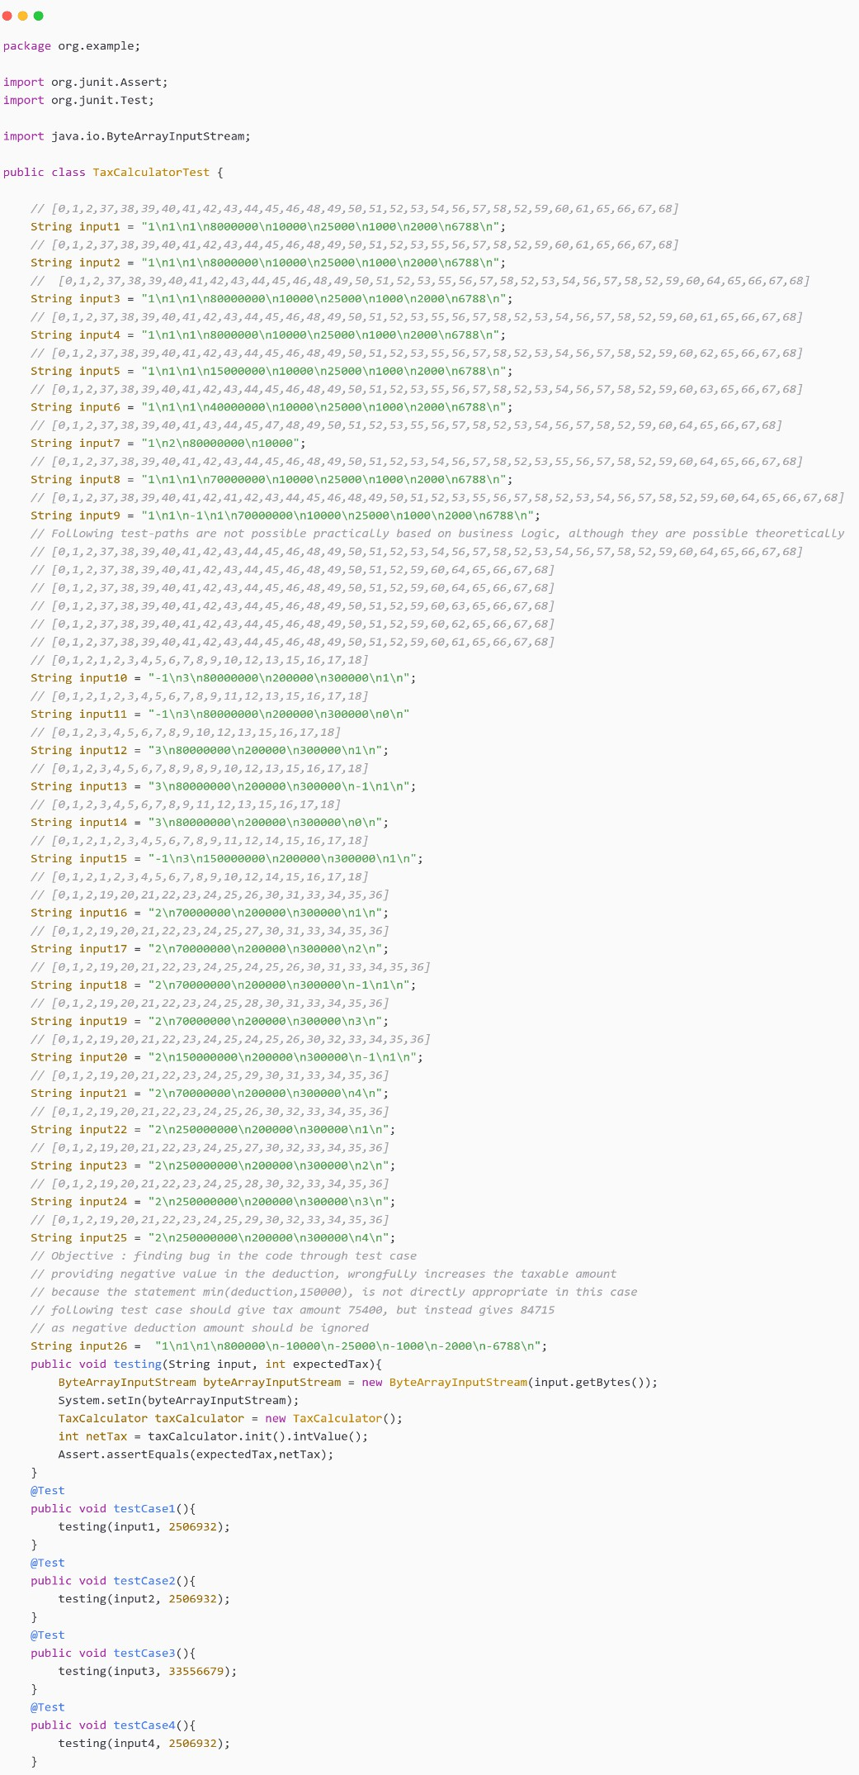

*Figure 3-22 TAX Calculator Test Code - I*

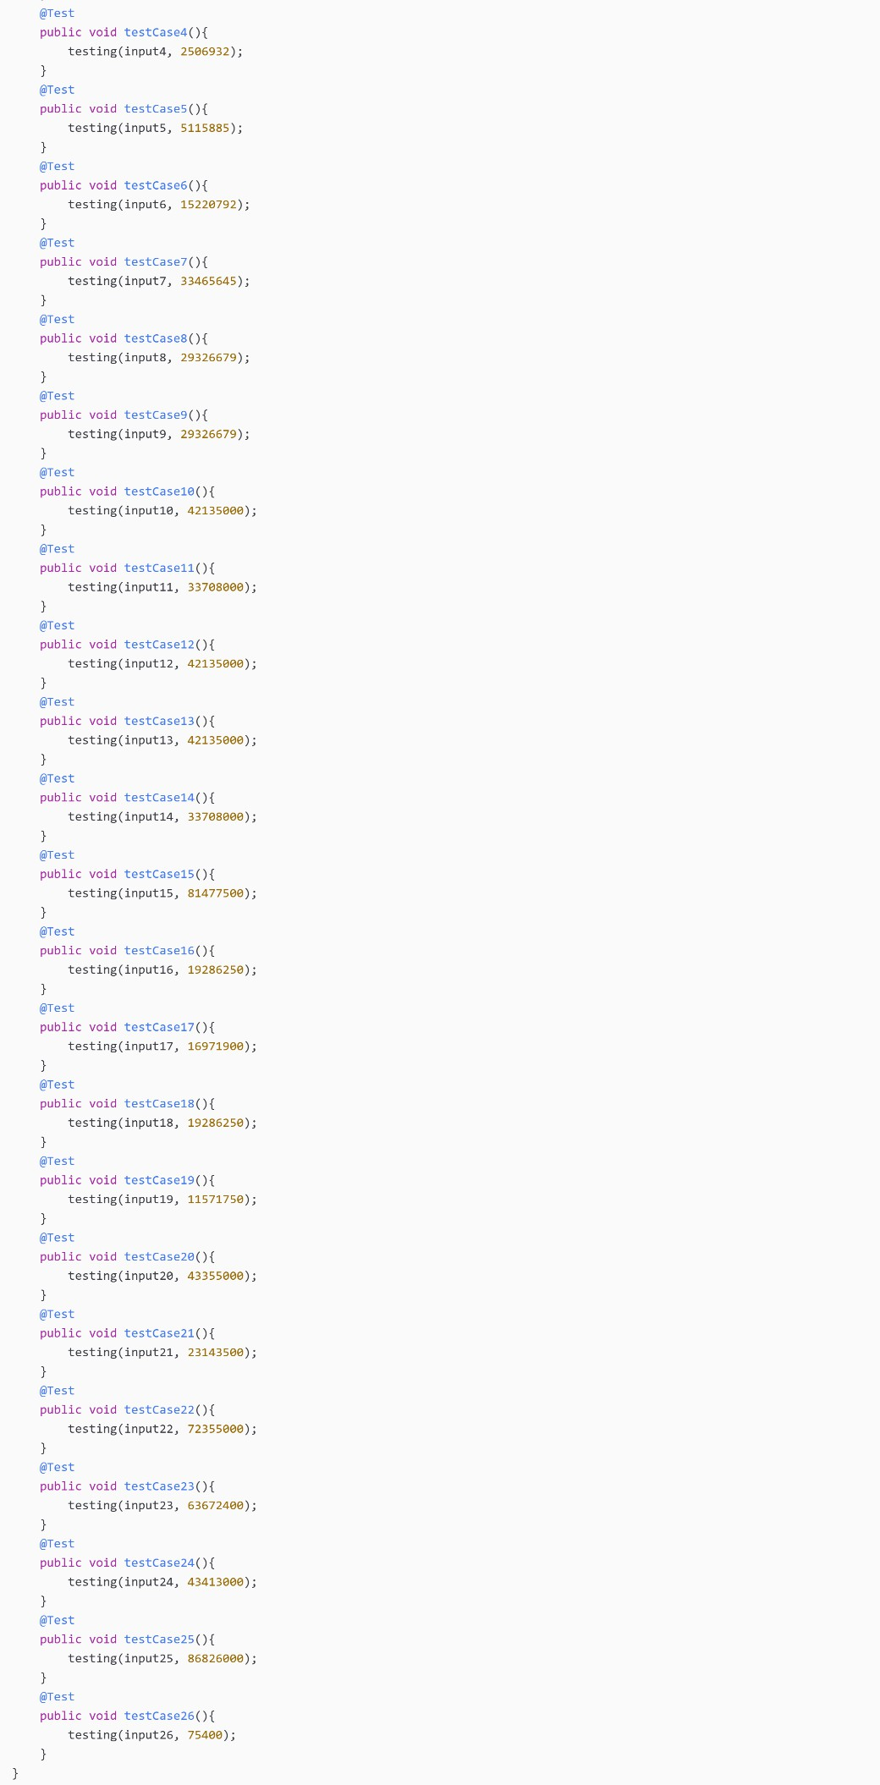

*Figure 3-23 TAX Calculator Test Code - II*

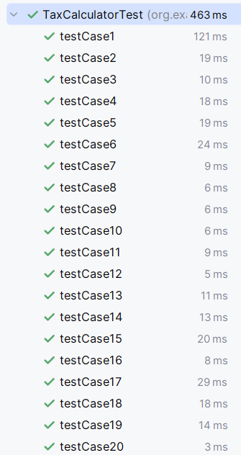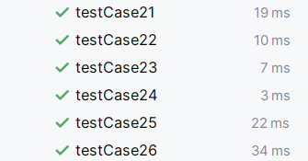

*Figure 3-24 TAX Calculator Test Cases*

### GOALSAVINGS CALCULATOR

**Data Flow Graph:**

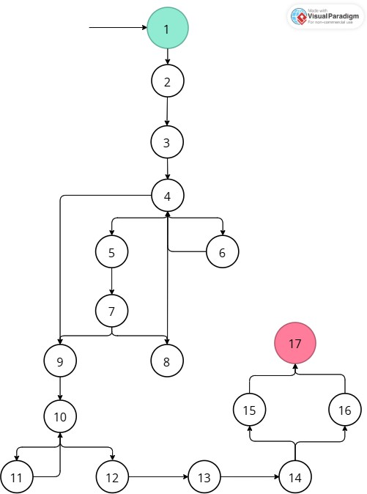

*Figure 3-25 GOALSAVINGS Calculator DFG*

|  |  |  |
| --- | --- | --- |
| **Variable** | **Definitions** | **Uses** |
| goalAmt | {2, 4} | {14, 16, (4, 6)} |
| initalSavings | {2, 5} | {14, (7, 8)} |
| retRate | {2, 5} | {14, 16, (7, 8)} |
| years | {2, 4} | {14, 16, (4, 6)} |
| freq | {2, 10} | {16, (10, 12)} |

|  |  |
| --- | --- |
| **Variable** | **All DU-Path Coverage** |
| goalAmt | {  [1,2,3,4,6,4,5,7,9,10,12,13,14,16,17],  [1,2,3,4,5,7,9,10,12,13,14,16,17]  } |
| initalSavings | {  [1,2,3,4,5,7,8,4,5,7,9,10,12,13,14,16,17],  [1,2,3,4,5,7,9,10,12,13,14,16,17]  } |
| retRate | {  [1,2,3,4,5,7,8,4,5,7,9,10,12,13,14,16,17],  [1,2,3,4,5,7,9,10,12,13,14,16,17]  } |
| years | {  [1,2,3,4,6,4,5,7,9,10,12,13,14,16,17],  [1,2,3,4,5,7,9,10,12,13,14,16,17]  } |
| freq | {  [1,2,3,4,5,7,9,10,11,10,12,13,14,15,17],  [1,2,3,4,5,7,9,10,12,13,14,15,17],  [1,2,3,4,5,7,9,10,12,13,14,16,17]  } |

|  |  |
| --- | --- |
| **Variable** | **All Def Coverage** |
| goalAmt | [1,2,3,4,6,4,9,10,12,13,14,16,17] |
| initalSavings | [1,2,3,4,5,7,8,4,5,7,9,10,12,13,14,16,17] |
| retRate | [1,2,3,4,5,7,8,4,5,7,9,10,12,13,14,16,17] |
| years | [1,2,3,4,6,4,9,10,12,13,14,16,17] |
| freq | [1,2,3,4,5,7,9,10,12,13,14,15,17] |

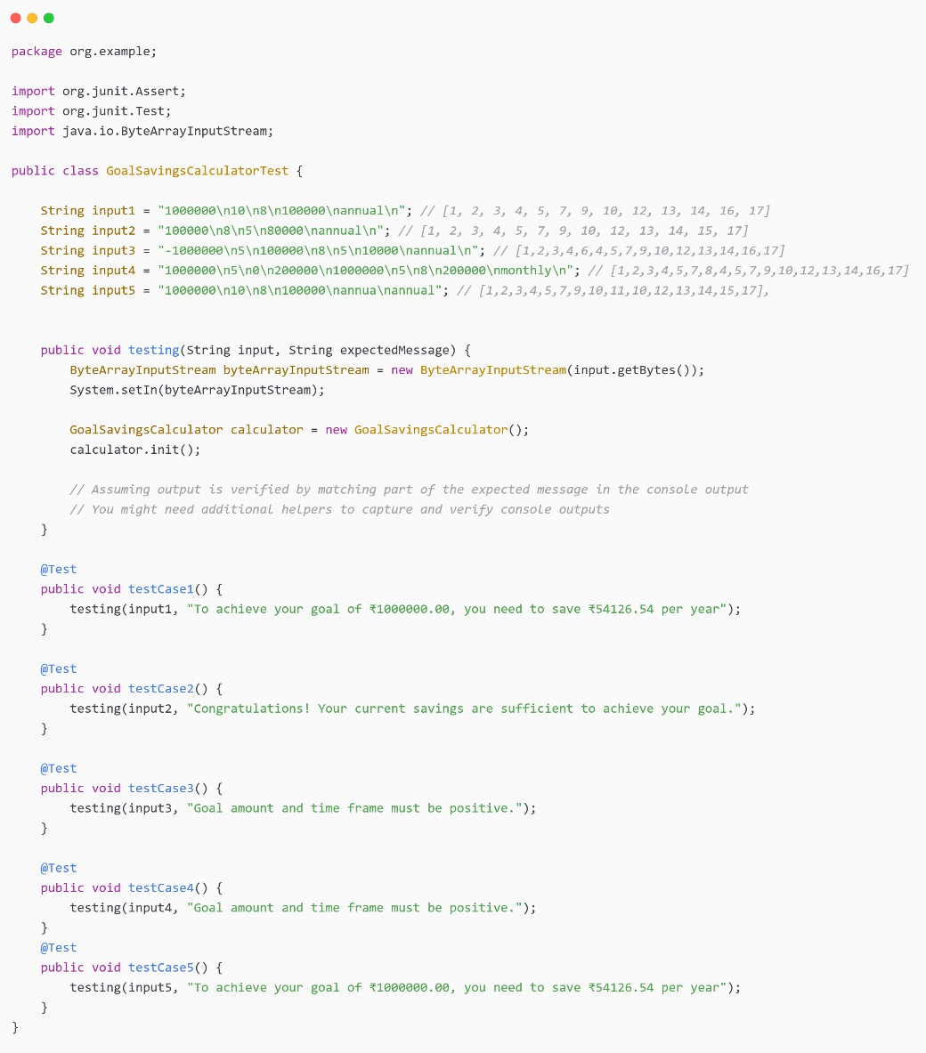

*Figure 3-26 GOALSAVINGS Calculator Test Code*

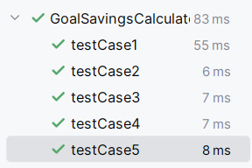

*Figure 3-27 GOALSAVINGS Calculator Test Cases*

### BUDGETPLANNING CALCULATOR

**Data Flow Graph:**

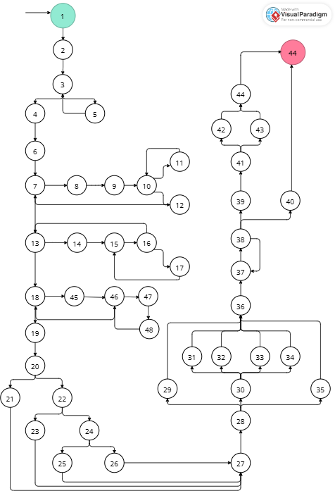

*Figure 3-28 BUDGETPLANNING Calculator DFG*

|  |  |  |
| --- | --- | --- |
| **Variable** | **Definitions** | **Uses** |
| monthlyIncome | {1, 3, 2} | {22, 24, 26, 29, (20, 22), (22, 24), (24, 26),  (28,29)} |
| emergencyFund | {1, 7} | {22, (30, 31), (30, 32), (30, 33)} |
| savingGoal | {1, 7} | {24, (30, 31), (30, 32), (30, 33)} |
| fixedEx | {1} | {13, 18} |
| varibleEx | {1} | {13, 18} |
| totalFixedEx | {19} | {19, 28} |
| totalVarEx | {19} | {19} |
| totalEx | {19} | {24, 26, 28, (20, 22), (22, 24), (24, 26), (30,31)} |
| emergencyAllocation | {19} | {22, 24, 26, 28, (22, 24), (24, 26), (30, 31), (30,  32), (30, 33)} |
| savingAllocation | {19} | {24, 26, 28, (24, 26), (30, 31), (30, 32)} |
| descriptionFunds | {19,23,25} | {26, 28, (28, 30)} |

|  |  |
| --- | --- |
| **Variable** | **DU Path** |
| monthlyIncome | {  [3,4,6,7,13,18,19,20,22],  [3,4,6,7,13,18,19,20,22,24],  [3,4,6,7,13,18,19,20,22,24,26],  [3,4,6,7,13,18,19,20,21,27,28,29],  [3,4,6,7,13,18,19,20,22,23,27,28,29],  [3,4,6,7,13,18,19,20,22,24,26,27,28,29],  [3,4,6,7,13,18,19,20,22,24,25,27,28,29]  } |
| emergencyFund | {  [7,13,18,19,20,22],  [7,13,18,19,20,21,27,28,30,31],  [7,13,18,19,20,21,27,28,30,32],  [7,13,18,19,20,21,27,28,30,33],  [7,13,18,19,20,22,23,27,28,30,31],  [7,13,18,19,20,22,23,27,28,30,32],  [7,13,18,19,20,22,23,27,28,30,33],  [7,13,18,19,20,22,24,26,27,28,30,31],  [7,13,18,19,20,22,24,26,27,28,30,32],  [7,13,18,19,20,22,24,26,27,28,30,33],  [7,13,18,19,20,22,24,25,27,28,30,31],  [7,13,18,19,20,22,24,25,27,28,30,32],  [7,13,18,19,20,22,24,25,27,28,30,33],  } |
| savingGoal | {  [7,13,18,19,20,22,24]  [7,13,18,19,20,21,27,28,30,31],  [7,13,18,19,20,21,27,28,30,32],  [7,13,18,19,20,21,27,28,30,33],  [7,13,18,19,20,22,23,27,28,30,31],  [7,13,18,19,20,22,23,27,28,30,32],  [7,13,18,19,20,22,23,27,28,30,33],  [7,13,18,19,20,22,24,26,27,28,30,31],  [7,13,18,19,20,22,24,26,27,28,30,32],  [7,13,18,19,20,22,24,26,27,28,30,33],  [7,13,18,19,20,22,24,25,27,28,30,31], |

|  |  |
| --- | --- |
|  | [7,13,18,19,20,22,24,25,27,28,30,32],  [7,13,18,19,20,22,24,25,27,28,30,33]  } |
| fixedEx | {  [1,2,3,4,6,7,13],  [1,2,3,4,6,7,13,18]  } |
| varibleEx | {  [1,2,3,4,6,7,13],  [1,2,3,4,6,7,13,18]  } |
| totalFixedEx | {  [19,20,21,27,28],  [19,20,22,23,27,28],  [19,20,22,24,26,27,28],  [19,20,22,24,25,27,28]  } |
| totalVarEx | No Path |
| totalEx | {  [19,20,22],  [19,20,22,24],  [19,20,22,24,26],  [19,20,21,27,28],  [19,20,22,23,27,28],  [19,20,22,24,26,27,28],  [19,20,22,24,25,27,28],  [19,20,21,27,28,30,31],  [19,20,22,23,27,28,30,31],  [19,20,22,24,26,27,28,30,31],  [19,20,22,24,25,27,28,30,31]  } |
| emergencyAllocation | {  [19,20,22],  [19,20,22,24],  [19,20,22,24,26],  [19,20,21,27,28],  [19,20,22,23,27,28],  [19,20,22,24,26,27,28],  [19,20,22,24,25,27,28],  [19,20,21,27,28,30,31],  [19,20,21,27,28,30,32],  [19,20,21,27,28,30,33],  [19,20,22,23,27,28,30,33],  [19,20,22,23,27,28,30,31],  [19,20,22,23,27,28,30,32],  [19,20,22,24,26,27,28,30,33],  [19,20,22,24,26,27,28,30,31],  [19,20,22,24,26,27,28,30,32],  [19,20,22,24,25,27,28,30,33],  [19,20,22,24,25,27,28,30,31],  [19,20,22,24,25,27,28,30,32]  } |

|  |  |
| --- | --- |
| savingAllocation | {  [19,20,22,24],  [19,20,22,24,26],  [19,20,21,27,28],  [19,20,22,23,27,28],  [19,20,22,24,26,27,28],  [19,20,22,24,25,27,28],  [19,20,21,27,28,30,31],  [19,20,21,27,28,30,32],  [19,20,21,27,28,30,33],  [19,20,22,23,27,28,30,33],  [19,20,22,23,27,28,30,31],  [19,20,22,23,27,28,30,32],  [19,20,22,24,26,27,28,30,33],  [19,20,22,24,26,27,28,30,31],  [19,20,22,24,26,27,28,30,32],  [19,20,22,24,25,27,28,30,33],  [19,20,22,24,25,27,28,30,31],  [19,20,22,24,25,27,28,30,32]  } |
| descriptionFunds | {  [19,20,22,24,26],  [19,20,21,27,28],  [19,20,21,27,28,30],  [19,20,22,24,26,27,28],  [19,20,22,24,26,27,28,30],  [23,27,28],  [23,27,28,30],  [25,27,28],  [25,27,28,30]  } |

**Observations:**

* The **Budget Planning Calculator CFG** consists of **49 nodes**, making manual identification of **All Def-Use (DU) paths** and **All Def paths** highly labor- intensive.
* There are **11 variables** in the function, each requiring test paths, which further increases the complexity of manual path enumeration.
* The tool used ([**http://cs.gmu.edu:8080/offutt/coverage/DFGraphCoverage**)](http://cs.gmu.edu:8080/offutt/coverage/DFGraphCoverage)) provided **DU paths**, but it did not generate **All-DU path Coverage** and **All-Def paths Coverage** for larger graphs.
* For smaller graphs, the tool performed better.
* Due to **tool limitations**, **All-DU paths** and **All-Def path coverage** were not performed for this particular function.

### RETIREMENT CORPUS CALCULATOR

**Data Flow Graph:**

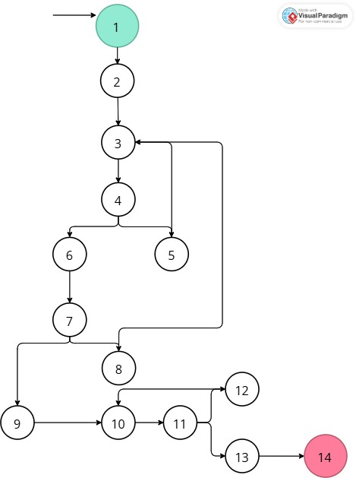

*Figure 3-29 RETIREMENT CORPUS Calculator DFG*

|  |  |  |
| --- | --- | --- |
| **Variable** | **Definitions** | **Uses** |
| currentAge | {2, 4} | {14, (14, 5)} |
| retirementAge | {2, 4} | {14, (4, 5), (7, 8)} |
| lifeExpectancy | {2, 6} | {14, (7, 8)} |
| currentExpenses | {2, 11} | {14, (11, 12)} |
| inflationRate | {2, 11} | {14, (11, 12)} |
| returnRate | {2, 11} | {14, (11, 12)} |

|  |  |
| --- | --- |
| **Variable** | **All DU-Path Coverage** |
| currentAge | {  [1,2,3,4,5,3,4,6,7,9,10,11,13,14],  [1,2,3,4,6,7,9,10,11,13,14]  } |
| retirementAge | {  [1,2,3,4,5,3,4,6,7,9,10,11,13,14],  [1,2,3,4,6,7,8,3,4,6,7,9,10,11,13,14],  [1,2,3,4,6,7,9,10,11,13,14]  } |
| lifeExpectancy | {  [1,2,3,4,6,7,8,3,4,6,7,9,10,11,13,14],  [1,2,3,4,6,7,9,10,11,13,14]  } |
| currentExpenses | {  [1,2,3,4,6,7,9,10,11,12,10,11,13,14],  [1,2,3,4,6,7,9,10,11,13,14]  } |
| inflationRate | {  [1,2,3,4,6,7,9,10,11,12,10,11,13,14],  [1,2,3,4,6,7,9,10,11,13,14]  } |
| returnRate | {  [1,2,3,4,6,7,9,10,11,12,10,11,13,14],  [1,2,3,4,6,7,9,10,11,13,14]  } |

|  |  |
| --- | --- |
| **Variable** | **All Def Coverage** |
| currentAge | [1,2,3,4,5,3,4,6,7,9,10,11,13,14] |
| retirementAge | [1,2,3,4,5,3,4,6,7,9,10,11,13,14] |
| lifeExpectancy | [1,2,3,4,6,7,8,3,4,6,7,9,10,11,13,14] |
| currentExpenses | [1,2,3,4,6,7,9,10,11,12,10,11,13,14] |
| inflationRate | [1,2,3,4,6,7,9,10,11,12,10,11,13,14] |
| returnRate | [1,2,3,4,6,7,9,10,11,12,10,11,13,14] |

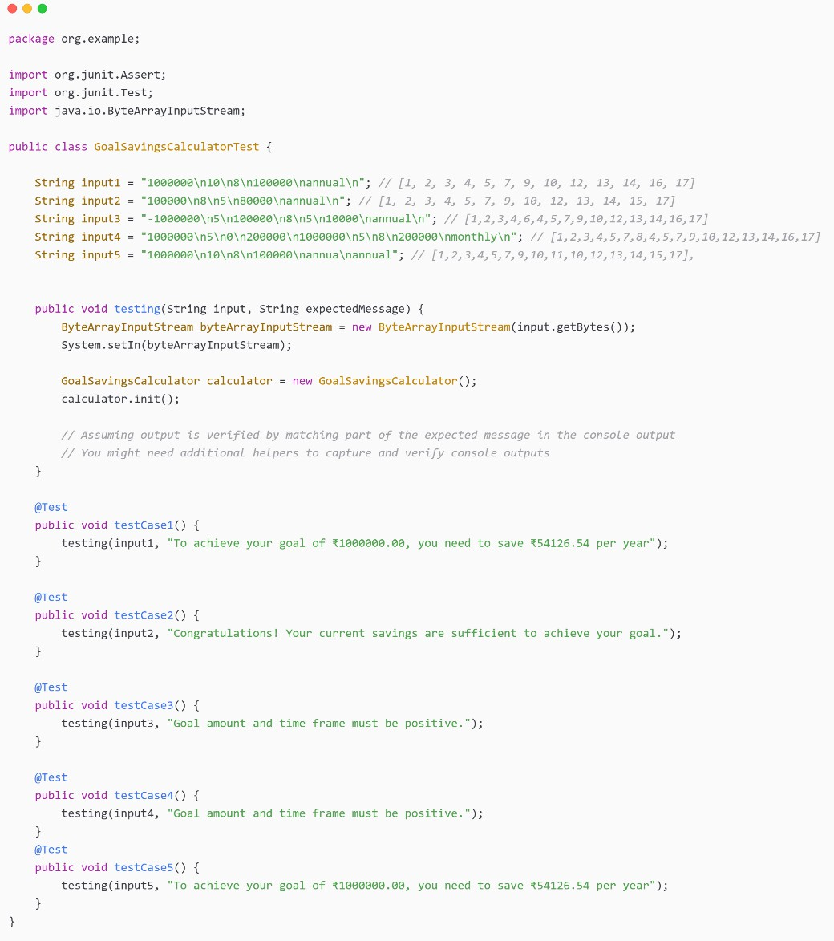

*Figure 3-29 RETIREMENT CORPUS Calculator Test Code*

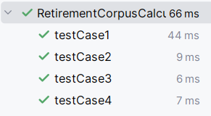

*Figure 3-30 RETIREMENT CORPUS Calculator Test Cases*

## REFERENCES

* **DFGraphCoverage:** [https://dfgraphcoverage.com](https://dfgraphcoverage.com/)
* **JUnit:** [https://junit.org](https://junit.org/)
* **Income Tax Department Site:** [https://incometaxindia.gov.in](https://incometaxindia.gov.in/)
* **ChatGPT:** [https://chat.openai.com](https://chat.openai.com/)
* **DFG:** <https://online.visual-paradigm.com/>
* **Code to Image:** https://10015.io/tools/code-to-image-converter
* **Software Testing PPT:** <https://shorturl.at/PDJ9Q>